Lowes to Lay Off Thousands of Workers
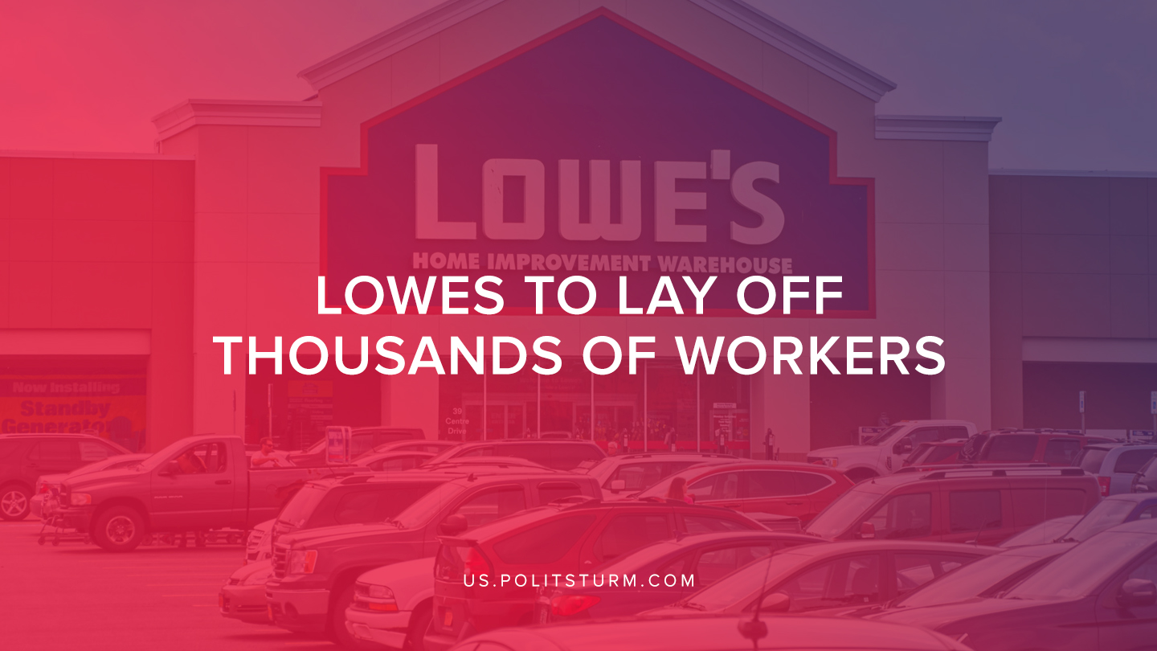

Original article
2019-08-05
1 min read

Lowes announced that it will be laying off thousands of workers across its stores. The company did not provide a concrete number of workers that would be laid off, but it did confirm that the decision would impact thousands of its workers.
The company’s most recent SEC filing showed that the company employed 190,000 workers and generated annual sales of $71.3 billion in the 2018 fiscal year.
While workers are losing their jobs and livelihoods, the shareholders are having a completely different experience. The company increased the amount of its dividend payable to investors from $0.48 per share to $0.55 per share.
While thousands of workers will be negatively impacted by the layoffs, investors continue to reap benefits. The capitalist economic system represents the dictatorship of the bourgeoisie, a system that primarily exists to serve the needs of the investors and provide for the growth of capital.
Sources:
1, 2, 3

Original article

