London Reached Record Homelessness in 2024
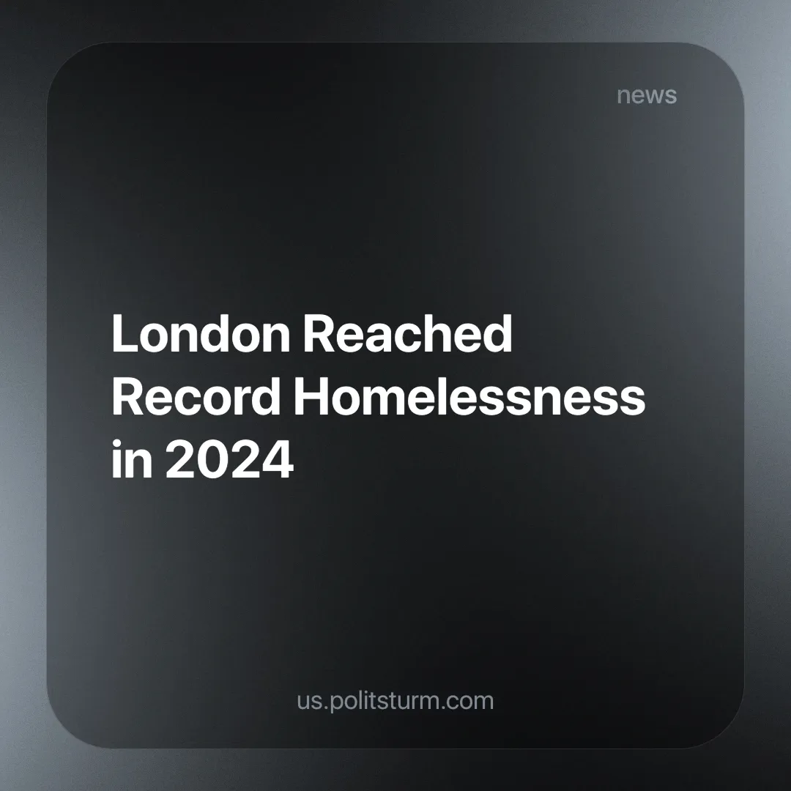

Original article
2025-02-14
4 min read

The Combined Homelessness and Information Network (CHAIN), an organisation funded by the Mayor of London and managed by Homeless Link (an organisation that works to improve services and seeks to campaign for policy changes that they believe will end homelessness), reported that the total number of rough sleepers — those without any shelter, forced to sleep on the streets, in bus stops, or other public spaces on a regular basis — was calculated to be 4,612, an increase of 5% from the previous year. Half of them are reported to have mental health problems [1].
Out of these, 704 were reported to be living on the streets, which represents a more severe and prolonged form of rough sleeping. CHAIN defines this group as those who have been frequently observed to be rough sleeping over a period of three weeks or more, indicating they are not just temporarily without shelter but are consistently homeless with no access to emergency accommodations, or homeless shelters. This is a 26% increase from the previous year.
2024 also saw the highest-ever level of homelessness in the capital. More than 183,000 Londoners were estimated to be homeless in the broader sense and living in temporary accommodations. The Mayor of London said that £4 million a day is spent on these temporary accommodations [2].
This comes as London is experiencing record numbers of long-term empty homes, reaching over 38,000 in 2024 [3]. Rent prices have risen significantly since 2016, following a dip in 2018 and 2021 [4], with the average rent in the city now standing at £2,086 per month [5].
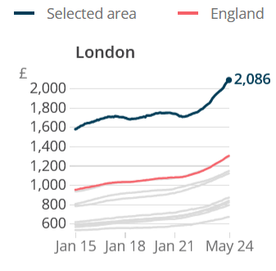
Despite the money spent on tackling the problem, it is impossible to completely eradicate homelessness under capitalism. The rate of home ownership can vary from country to country, but in a capitalist system, where the main driving force is the search for profit, having a roof over one’s head and employment are not guaranteed.
A majority of people must make a living by selling off their labour power to the capitalist class in exchange for a wage. But in capitalism, job insecurity due to redundancies or companies failing due to capitalist competition can leave many workers without employment — without income.
Without being able to sell their labour-power, workers are many times left unable to afford their rent or mortgage, and thus end up homeless — this can be expressed by having to live at someone else’s residence, at a homeless shelter or on the streets.
Additionally, many in the government are landlords or are lobbied to push for policies that favour them. A state in a capitalist system (or in any social-economic system) cannot act as an independent force above classes but arises out of class relations and serves the interests of the dominant class of that system.
Governments often will talk about tackling homelessness, as it is a popular demand even to capitalists — if for no more than aesthetic reasons. However, they are usually slow to act when tackling this issue and are very ineffective.
The 1988 Housing Act, for example, allows landlords to evict tenants without reason, meaning people could be kicked out of their residence with little warning or “reason” or time to find new accommodation. A reform to end no-fault evictions is only now making its way through Parliament, after many delays [6].
It is necessary to replace the socio-economic system with one that represents the interests of the workers, in which the common wants and needs of working people are the driving force, rather than the maintenance of profits.
Under socialism, it is in the interest of society to guarantee good quality housing for everyone. Soviet citizens were all guaranteed a place to live, residences had strict minimum standards — such as having at least five square meters of living space per person, and if the dwelling was overcrowded, the residents would be put on a waiting list to be reallocated [7].
The waiting lists could be very long and, due to the massive destruction of housing during the Second World War there was high demand in the 50s-60s and corners were occasionally cut with building materials or techniques. But, throughout it all, even during the hardships of war, rent was extremely cheap (sometimes non-existent) and utilities were highly subsidised (often less than 4% of a worker’s salary).
Despite its flaws — much of which was exacerbated by extremely unfavourable conditions in which the Soviet Union found itself — the socialist state was able to guarantee housing to every one of its citizens.
Politsturm aims to lay the foundations for the creation of communist parties that can lead workers in the struggle for socialism. If you want to contribute to this work, consider joining.
Sources:
[1] BBC — People living on London's streets rises by 26% — 31/01/2025
[2] BBC — Cost of housing homeless people in London £4m a day — 25/10/2024
[3] Action on Empty Homes — In London, Long-Term Empty Homes Have Nearly Doubled Since 2016 — 21/11/2024
[4] Office for National Statistics — Index of Private Housing Rental Prices, UK: January 2024 — 14/02/2024
[5] Office for National Statistics — Private rent and house prices, UK: June 2024 — 19/06/2024
[6] Sky News — What is Labour's Renters' Rights Bill - and will it end no-fault evictions? — 12/09/2024
[7] Proceedings of the Academy of Political Science, Vol. 35, No. 3, The Soviet Union in the 1980s (1984), pp. 69-80

Original article

