Lockheed Martin and HIMARS: How to Profit from the War?
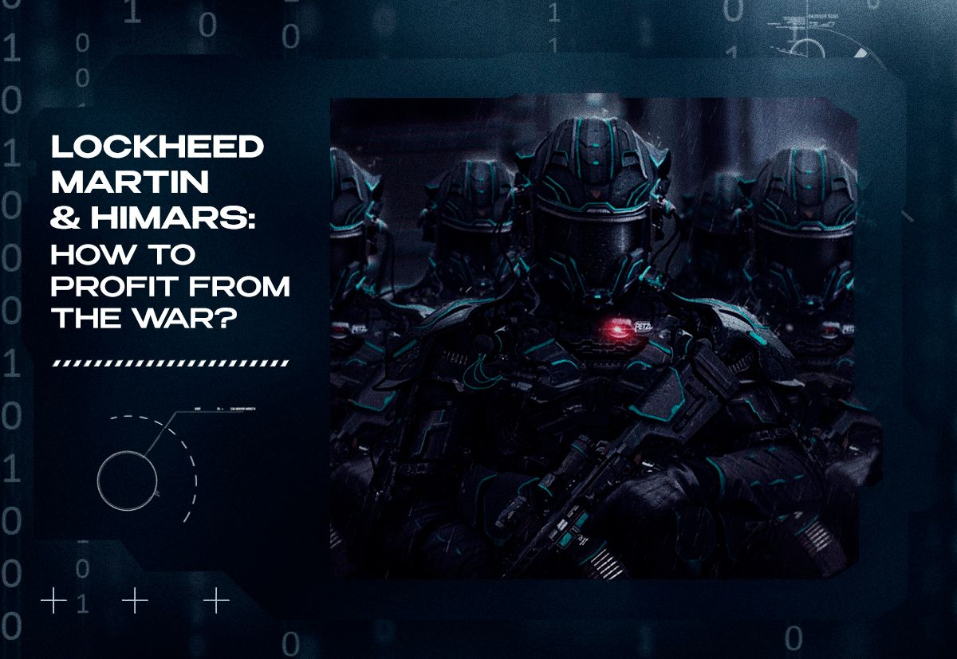

Original article
2023-10-25
10 min read

The "Special Military Operation" that unfolded in 2022 served as an occasion for powerful Western capitalist countries to provide military support to Ukraine. Officially declaring its mission as "deterring Russian aggression", the NATO alliance is actively carrying out the 1941 lend-lease act to equip Ukraine.
The United States of America was immediately at the forefront of the organizers of assistance to Ukraine. The United States plays the role of the world hegemon and, accordingly, the leading role in the military-political alliance of NATO. Without its current position as the leading economy in the world, the United States would not possess its immense strength. As a consequence, the military-industrial complex subsequently plays an essential role within the US economy.
Taking into account what was previously stated, "SMO" almost immediately challenged the capabilities of the American military-industrial complex. In light of this, Politsturm considers it interesting to conduct a brief analysis of the activities of one of the most prominent representatives of the contractors of the US military-industrial complex – Lockheed Martin, especially in the context of the events of the past year.
The Lockheed Martin concern was founded in 1995 as a result of the merger of Lockheed Corporation and Martin Marietta. The main areas of activity of this company are aircraft construction, shipbuilding, electronics for the space industry, as well as the automation of communication routes. Such a wide range of manufactured equipment and maintenance programs allowed this corporation to establish itself as a reliable contractor for the US military-industrial complex.
In addition to high-tech products for civilian needs, this concern is also engaged in the production of weapons systems. First of all, we are talking about the production of army and strategic aviation for the needs of the US Air Force, especially the F-16, F-22 Raptor, and F-35 fighters of the latest generations. These fighters make up the power of the airspace of NATO countries.
The company has also succeeded in the production of military equipment for the needs of the ground forces. Compose primarily of PC30, 270 MLRS and the famous M142 HIMARS. Although the debut of these rocket artillery systems took place during a series of wars in the Middle East, they gained special notoriety during the second phase of the armed conflict in Ukraine.
The main technical feature of these MLRS is the ability to conduct both volley fire and surgically "sting" with extended-range rocket ammunition.The rocket projectile with the farthest range, the ATACMS,is capable of traveling 300 kilometers.
However, the US military leadership is not in a hurry to give them to the Ukrainian side yet, the primary intention is to assist Ukraine regain its territorial possessions within the perimeters established in 1991. inevitably these MLRS installations were given to Ukraine. Furthermore, when the Western military and political leadership searches for the Kremlin's "red lines," they act more forcefully and aggressively each time. In the future, the ATACMS issue may be resolved in favor of the APU.
The production of HIMARS brings fabulous profits to capitalists. This statement is easily proved by the financial success of this contractor of the US military-industrial complex.
First of all, this is evidenced by the growth dynamics of Lockheed Martin shares - from mid-October 2022 to the beginning of 2023, their price increased from $ 388 to $ 486. Exceptional commercial success allowed Lockheed Martin to receive an order from the Pentagon for $ 431 million in the specified time period.
As a result, the revenue of the arms concern in the 4th quarter of 2022 increased by 7%, exceeding many expectations. The artillery systems production department alone increased revenue by 8% to $4 billion. The secret of this success is extremely simple - the abundance of military orders. Artificially inflated demand has generated such an artfully inflated supply.
It is worth remembering that MLRS is not the only source of income for this arms concern. The list of products supplied to the needs of the Armed Forces of Ukraine also includes hand-held portable anti-tank missile systems - mainly Javelin (the company promised to increase their production by almost 2 times in 2023) and NLAW.
At the same time, the arms concern is also interested in increasing the production of F-16 combat aircraft and is participating in a contract worth $3.75 billion on the purchase of M1A Abrams tanks by the Polish government. This fact also allows us to assert the benefits of Lockheed Martin from the "tank deal" - Poland receives "Abrams" instead of the T-72-PT-91 transferred to Ukraine, and contractors receive enormous profits.
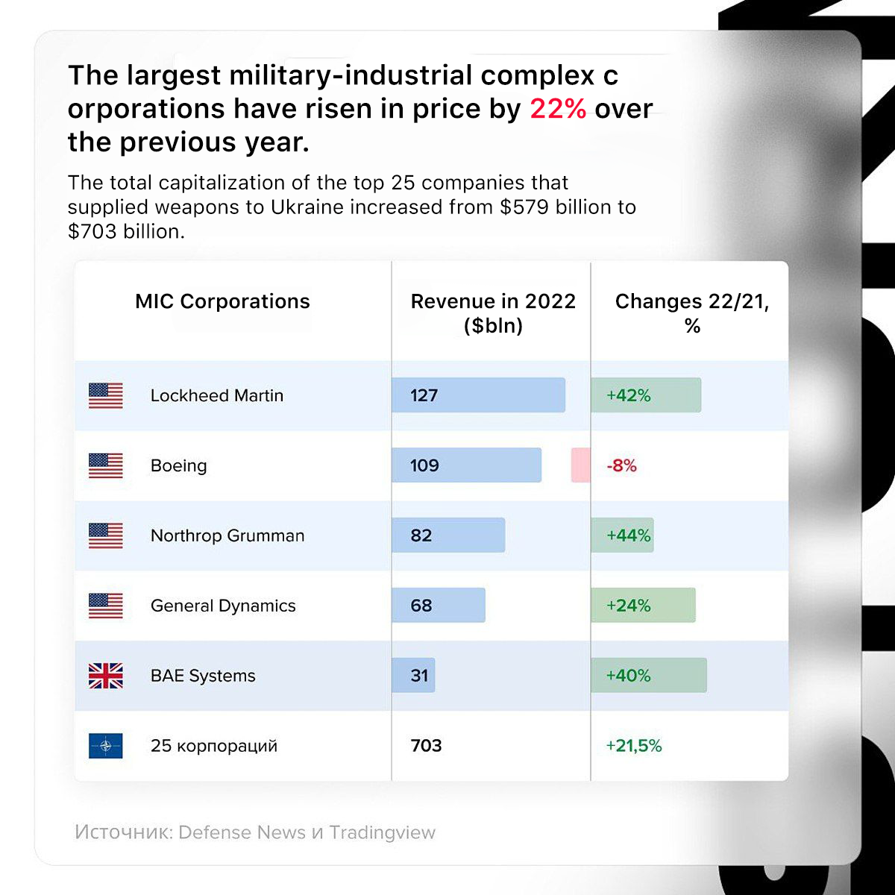
The growth of capitalization of companies engaged in the supply of weapons
As a result, in 2022, Lockheed Martin's revenue amounted to $127 billion, which is 42% more than in 2021.At the same time, anyone who is even remotely interested in general affairs has most likely heard about the exit of several Western corporations from the Russian market.Technically, Lockheed Martin was not present at it either before the events of February 24, 2022, or after.
However, to everyone's surprise, on January 28, 2023, a fact appeared before the public – the shares of this large contractor of the US military-industrial complex are freely traded on the Public Joint-Stock Company "SPB Exchange", the largest stock exchange in Russia, which sells shares of foreign companies. And the Potanin-absorbed Tinkoff Bank still enables them to be purchased, carefully informing the potential buyer about their history.
Most frequently mentioned saying about 300% profit, often attributed to Marx, illustrates the greed and exploitation inherent in capitalism. Marx argued that capitalism is a system in which the capitalists (the owners of the means of production) exploit the workers (who have only their labor power to sell) in order to generate profits. Marx believed that this exploitation is inherent to capitalism, and that it can never be truly reformed.This is a well-known truth. It would be appropriate to mention how Marx formulated the main law of capitalism.
"Production of surplus-value is the absolute law of this mode of production."
No less relevant is the definition of the basic economic law of capitalism in the era of the domination of monopolies, given by Comrade Stalin in the post-war fundamental economic work "Economic Problems of Socialism in the USSR":
"The securing of the maximum capitalist profit through the exploitation, ruin, and impoverishment of the majority of the population of the given country, through the enslavement and systematic robbery of the peoples of other countries, especially backward countries, and, lastly, through wars and militarization of the national economy, which are utilized for the obtaining of the highest profits."
The last quote is not idle - Lockheed Martin is indeed a monopolist. Undoubtedly, this contractor of the US military-industrial complex is not an absolute monopolist in the arms market, but the concern owns truly colossal market shares in the production of combat aircraft, manual anti-tank systems, and MLRS.
Thus, this concern occupies a niche of one of the monopolists tied up in a cartel with other major contractors of the US military-industrial complex, such as Raytheon Technologies, Boeing, General Dynamics, and Northrop Grumman. In mainstream economics, this is called "oligopolies" and/or "monopolistic competition".
In addition, the tightening of the "SMO" in Ukraine pushes this company to even greater expansion. In early February 2023, Rheinmetall, another major arms concern of the NATO military-political alliance, announced the start of negotiations with Lockheed Martin on the production of HIMARS systems at its production base.
At the same time, the ownership structure of this concern is of particular interest:

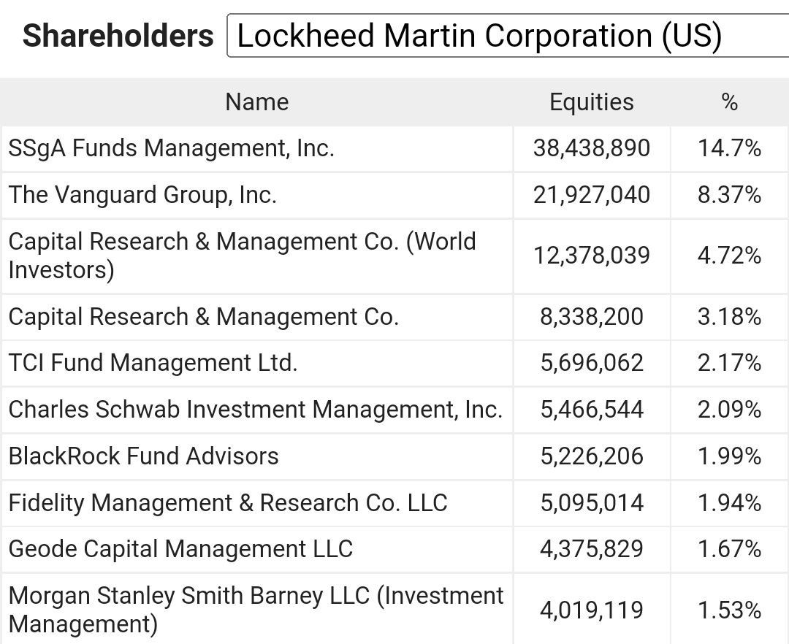
List of Lockheed Martin's largest shareholders
As can be seen from the atached list, the beneficiaries of Lockheed Martin are exclusively the largest American investment funds. Among them are the "Big Three from Wall Street" represented by State Street Corporation (14.7%), Vanguard Group (8.37%), and BlackRock (1.99%), which own the largest blocks of shares in most well-known multinational corporations.
This situation proves the correctness of Lenin's thesis about the new role of banks (the conceptual development of which investment funds act) in the era of the last stage of capitalism:
"As banking develops and becomes concentrated in a small number of establishments, the banks grow from modest middlemen into powerful monopolies having at their command almost the whole of the money capital of all the capitalists and small businessmen and also the larger part of the means of production and sources of raw materials in any one country and several countries. This transformation of numerous modest middlemen into a handful of monopolists is one of the fundamental processes in the growth of capitalism into capitalist imperialism; At the same time a personal link-up, so to speak, is established between the banks and the biggest industrial and commercial enterprises, the merging of one with another through the acquisition of shares, through the appointment of bank directors to the Supervisory Boards (or Boards of Directors) of industrial and commercial enterprises, and vice versa."
This position expressed in the fundamental economic work "Imperialism as the highest stage of capitalism" acquires a new relevance in the conditions of the 21st century. Especially in light of the enormous influence of American investment funds and banks on the political establishment of the "collective West", up to, in fact, the direct co-optation of members of their boards and boards of directors to the posts of ministers, advisers, and senators.
In light of these events, there is hardly any doubt that not only Lockheed Martin and other arms concerns, but also their above-mentioned beneficiaries, are interested in the further development of the military conflict in Ukraine.
Under these conditions, the reader is strongly encouraged to study Marxist theory to independently reveal the true interests of various powers. Follow our activities and join our Marxist clubs. Only an in-depth study of the theory can provide answers to the questions of topical everyday life.

Original article

