Local and Mayoral Elections in the UK: the Results
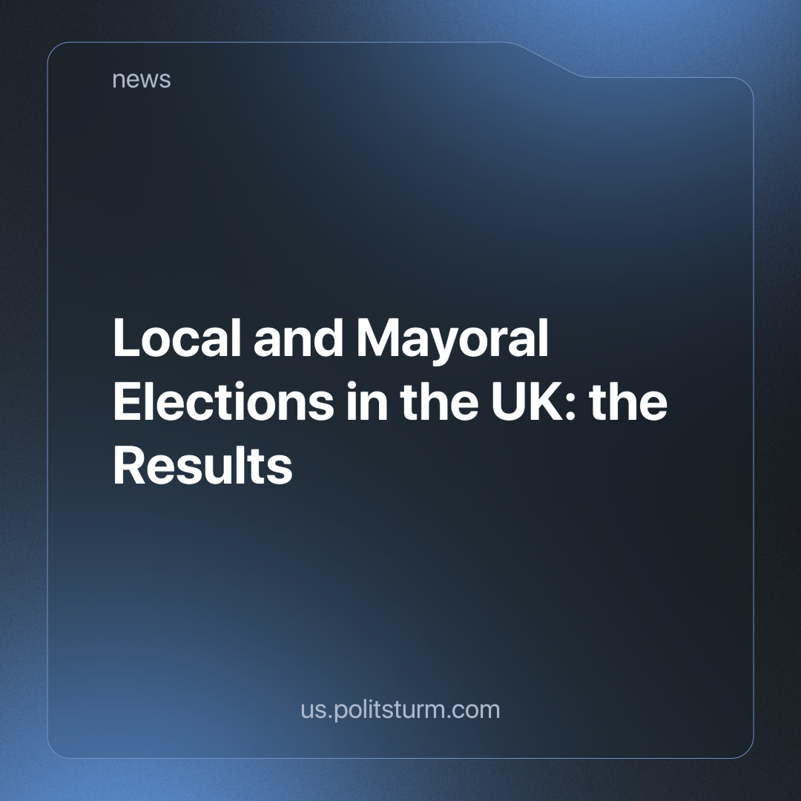

Original article
2024-05-07
2 min read

On May 2ndLocal council and Mayoral elections took place in the United Kingdom. We have previously covered the historical context of these elections and the low and still decreasing turnout, and we will go over the results.
In terms of the local councils, the ruling Conservative party lost 474 councillors almost half of them – they have 522 remaining. while the gains by the main opposition party – Labour, were only modest, gaining 186 councillors, now having 1,158 in total. Other beneficiaries include independents, of which there are now 228 councillors, an increase of 93, as well as the Greens who now have 181 councillors, up 74 from the last election [1]
Regarding the mayoral elections 10 out of the 11 areas now have a Labour party mayor, while the Conservative party now only have one. The only difference from before is the West Midlands Mayoral seat changed from Conservative to Labour [1].
In terms of turnout, these elections had amongst the lowest turnout ever. The nationwide average turnout for the mayoral elections was 29.96% [2], while for the council elections not all regions have reported turnout yet, but it seems as if the average is in the low 30%.
Due to their poor performance, even the leader of the Conservative party and current Prime Minister, Rishi Sunak, believes Labour will outperform them in the upcoming general election [3]. However, he believes that Labour will not win a majority in parliament, based on research extrapolating the results of these local elections [4]
Regardless, the plummeting turnout figures that we previously highlighting reveal that the British people are losing faith in liberal politics. As previously mentioned, the lowest turnout is amongst the poorest section of the population. The working class of Britain is realising through their own experience that the status quo does not work for them, and most realise that the Labour party doesn’t represent something significantly different, either.
The position of communists is abysmal with several opportunist communist parties which we have previously criticised in detail. As a result, we do not yet have a real communist party and are not in a strong enough position to lead the workers out of this impasse towards a system that truly reflects their interest to the full extent – socialism. However, it is not too late to build such a party. We are participating in such work. Join us to get involved.
Sources:
[1] https://www.bbc.co.uk/news/election/2024/england/results#council-scoreboard
[2] https://www.theguardian.com/politics/ng-interactive/2024/may/02/local-elections-2024-full-council-results-for-england
[3] https://www.msn.com/en-gb/news/uknews/rishi-sunak-admits-tories-may-not-win-general-election/ar-BB1lSgtW
[4] https://www.theguardian.com/politics/article/2024/may/06/hung-parliament-uk-general-election-rishi-sunak

Original article

