Leon Feuchtwanger on Liberty and Humanism
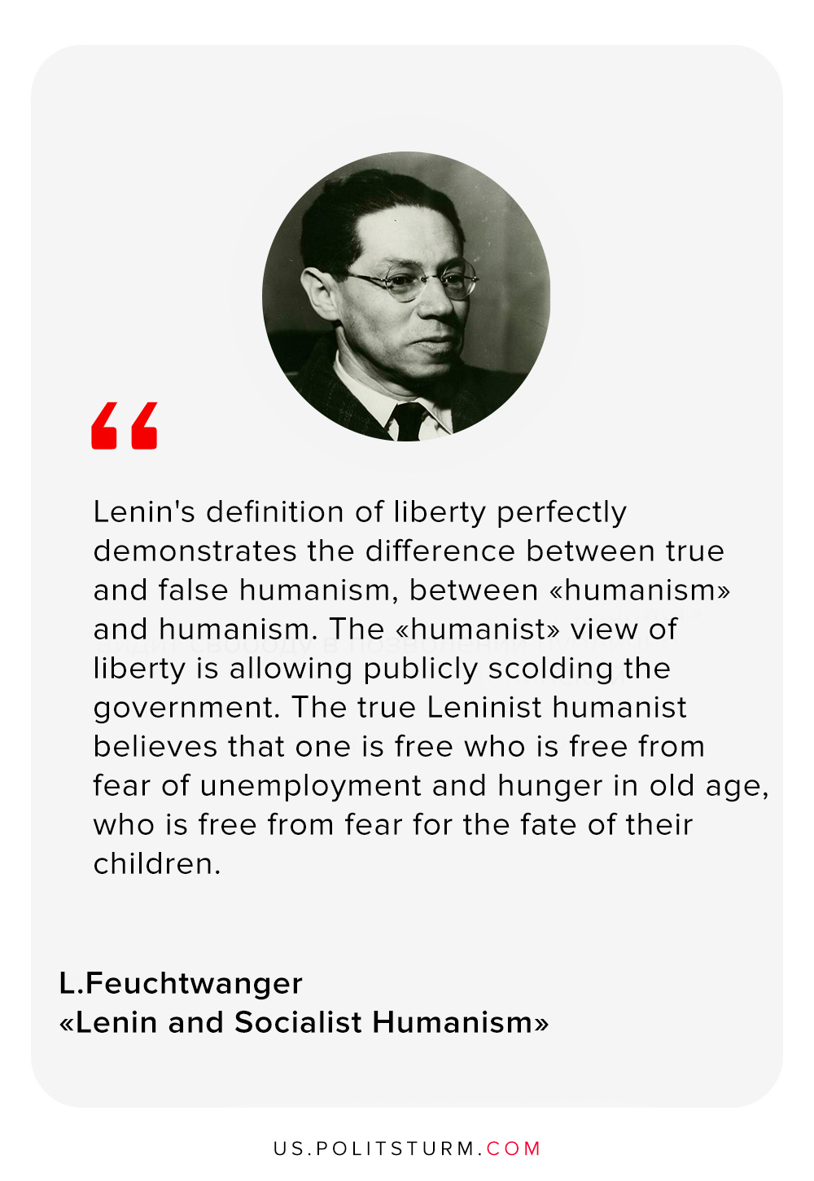

Original article
2020-03-02

Lenin’s definition of liberty perfectly demonstrates the difference between true and false humanism, between “humanism” and humanism. The “humanist” view of liberty is allowing publicly scolding the government. The true Leninist humanist believes that one is free who is free from fear of unemployment and hunger in old age, who is free from fear for the fate of their children.
– Leon Feuchtwanger. “Lenin and Socialist Humanism”

Original article

