Lenin on World Imperialism and Revolution
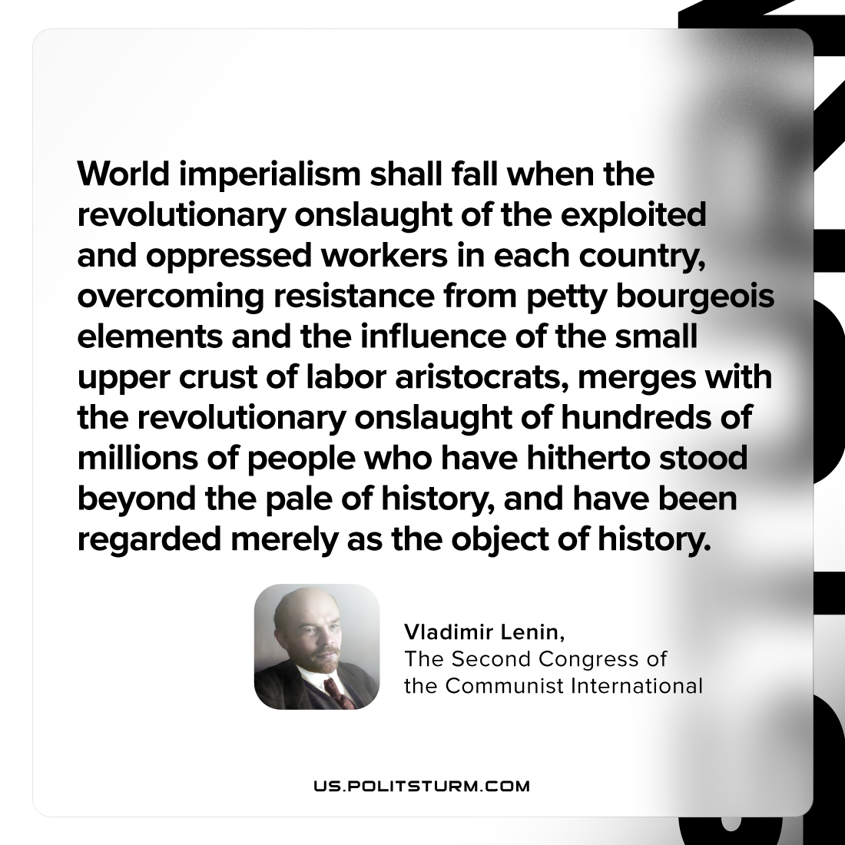

Original article
2023-05-28

"World imperialism shall fall when the revolutionary onslaught of the exploited and oppressed workers in each country, overcoming resistance from petty-bourgeois elements and the influence of the small upper crust of labor aristocrats, merges with the revolutionary onslaught of hundreds of millions of people who have hitherto stood beyond the pale of history, and have been regarded merely as the object of history."
Vladimir Lenin, “The Second Congress Of The Communist International”

Original article

