Lenin on Working Class Unity
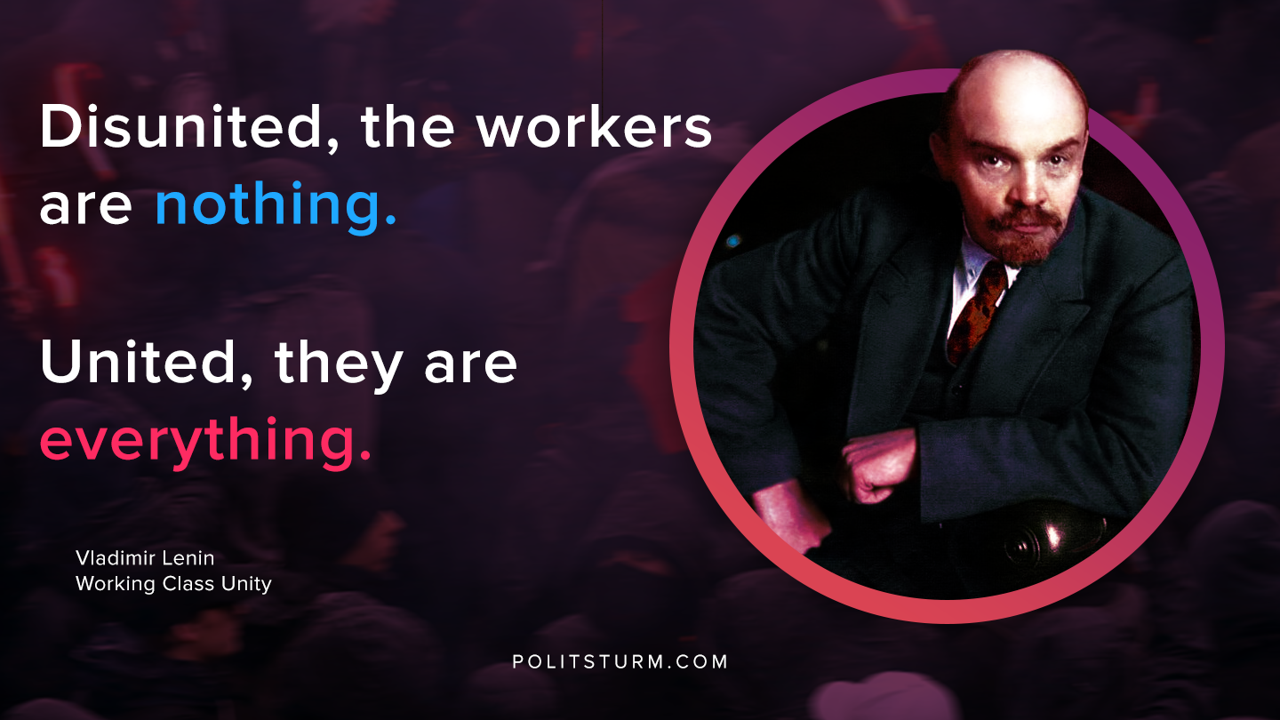

Original article
2020-08-16

Disunited, the workers are nothing. United, they are everything.
Vladimir Lenin, “Working Class Unity”.

Original article

