Lenin on Workers’ Organization
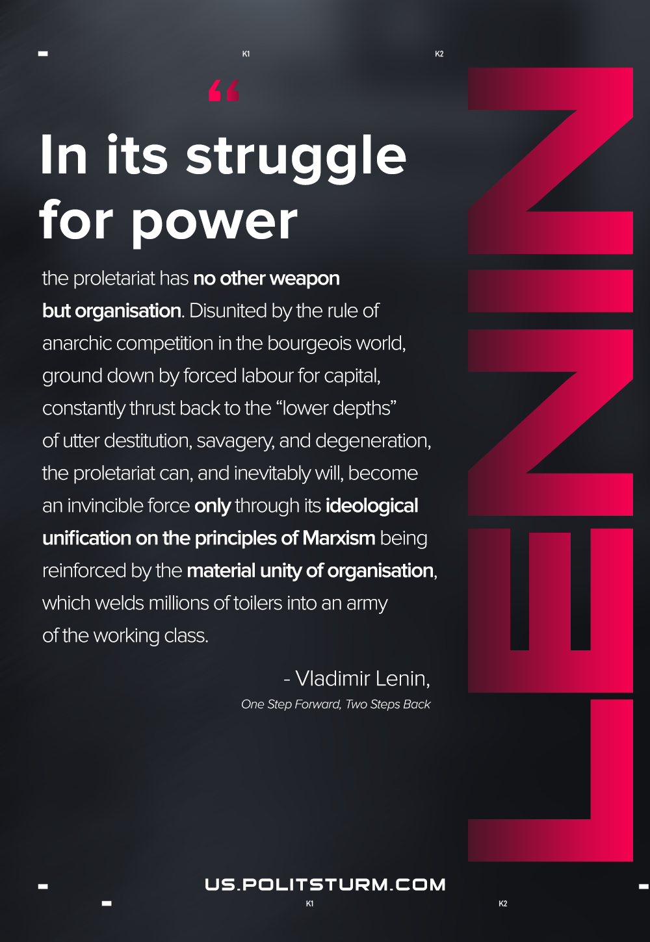

Original article
2021-02-05
1 min read

In its struggle for power the proletariat has no other weapon but organization. Disunited by the rule of anarchic competition in the bourgeois world, ground down by forced labor for capital, constantly thrust back to the “lower depths” of utter destitution, savagery, and degeneration, the proletariat can, and inevitably will, become an invincible force only through its ideological unification on the principles of Marxism being reinforced by the material unity of organization, which welds millions of toilers into an army of the working class.

Vladimir Lenin, One Step Forward, Two Steps Back

Original article

