Lenin on Workers' Control
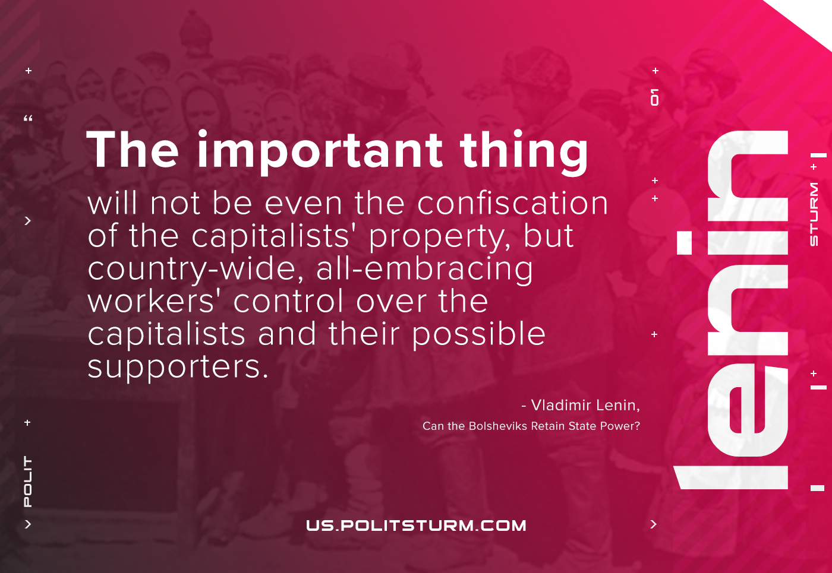

Original article
2021-06-03

The important thing will not be even the confiscation of the capitalists’ property, but country-wide, all-embracing workers’ control over the capitalists and their possible supporters.
Vladimir Lenin, Can the Bolsheviks Retain State Power?

Original article

