Lenin on Wealth
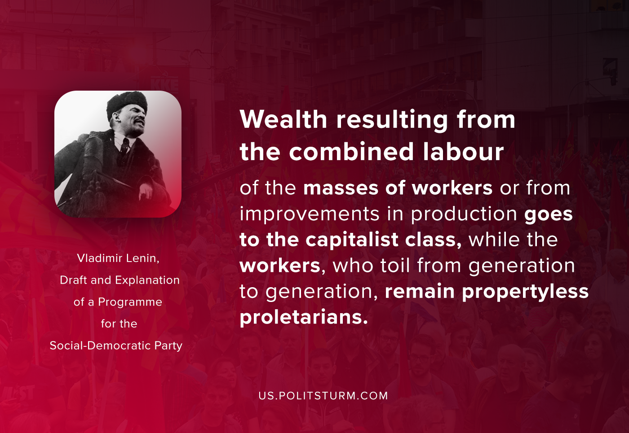

Original article
2020-10-05
1 min read

Wealth resulting from the combined labour of the masses of workers or from improvements in production goes to the capitalist class, while the workers, who toil from generation to generation, remain propertyless proletarians. That is why there is only one way of ending the exploitation of labour by capital, and that is to abolish the private ownership of the instruments of labour, to hand over all the factories, mills, mines, and also all the big estates, etc., to the whole of society and to conduct socialist production in common, directed by the workers themselves.
Vladimir Lenin, Draft and Explanation of a Programme for the Social-Democratic Party.

Original article

