Lenin on War and the Activity of the Masses
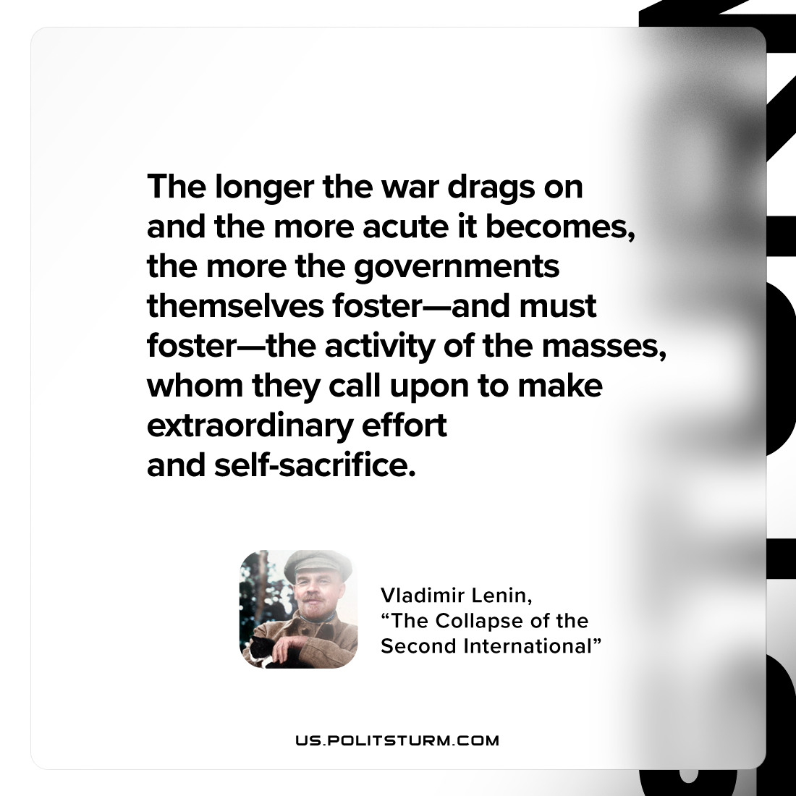

Original article
2022-12-08

"The longer the war drags on and the more acute it becomes, the more the governments themselves foster—and must foster—the activity of the masses, whom they call upon to make extraordinary effort and self-sacrifice."
Vladimir Lenin, "The Collapse of the Second International"

Original article

