Lenin on War and Capitalism
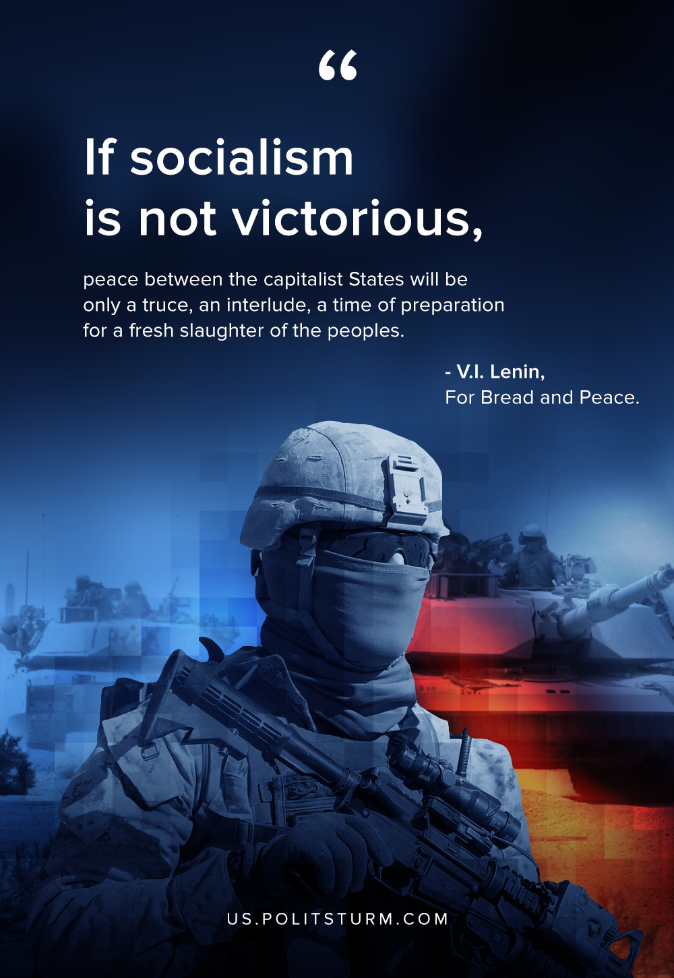

Original article
2019-12-10

If socialism is not victorious, peace between the capitalist States will be only a truce, an interlude, a time of preparation for a fresh slaughter of the peoples. Peace and bread are the basic demands of the workers and the exploited.
V.I. Lenin, “For Bread and Peace”.

Original article

