Lenin on Violence
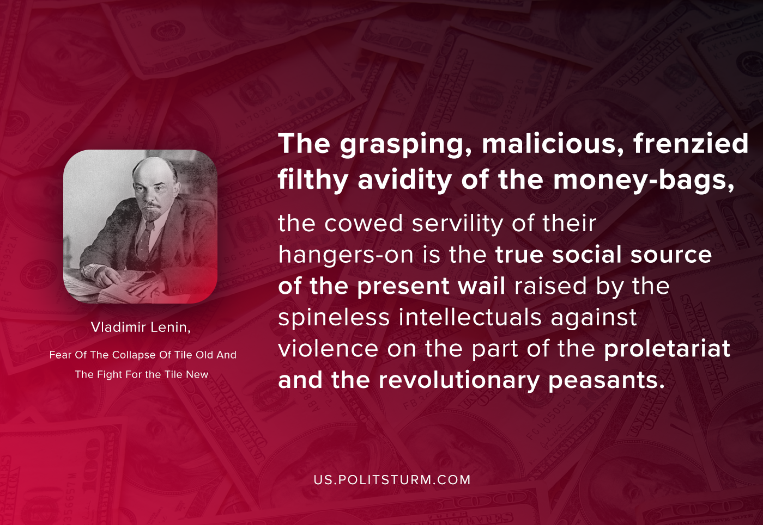

Original article
2020-10-07

The grasping, malicious, frenzied filthy avidity of the money-bags, the cowed servility of their hangers-on is the true social source of the present wail raised by the spineless intellectuals — from those of Rech to those of Novaya Zhizn — against violence on the part of the proletariat and the revolutionary peasants.
Vladimir Lenin, Fear Of The Collapse Of Tile Old And The Fight For Tile New

Original article

