Lenin on the Alliance of Opportunists and Capitalists
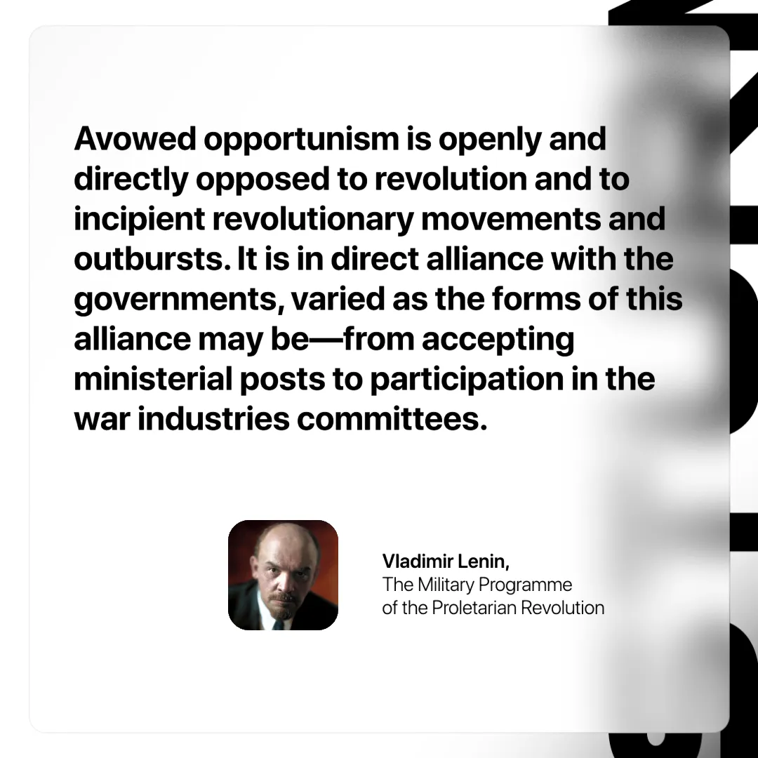

Original article
2025-06-05

“Avowed opportunism is openly and directly opposed to revolution and to incipient revolutionary movements and outbursts. It is in direct alliance with the governments, varied as the forms of this alliance may be—from accepting ministerial posts to participation in the war industries committees.”
Vladimir Lenin, The Military Programme of the Proletarian Revolution

Original article

