Lenin on Unity
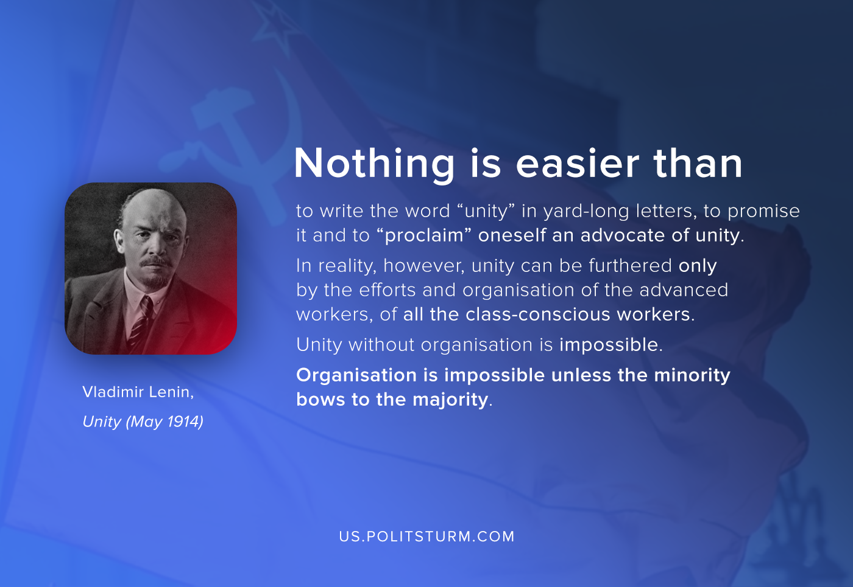

Original article
2020-08-27

Nothing is easier than to write the word “unity” in yard-long letters, to promise it and to “proclaim” oneself an advocate of unity. In reality, however, unity can be furthered only by the efforts and organisation of the advanced workers, of all the class-conscious workers.
Unity without organisation is impossible. Organisation is impossible unless the minority bows to the majority.
Vladimir Lenin. Unity (May 30, 1914)

Original article

