Lenin on Unity With the Opportunists
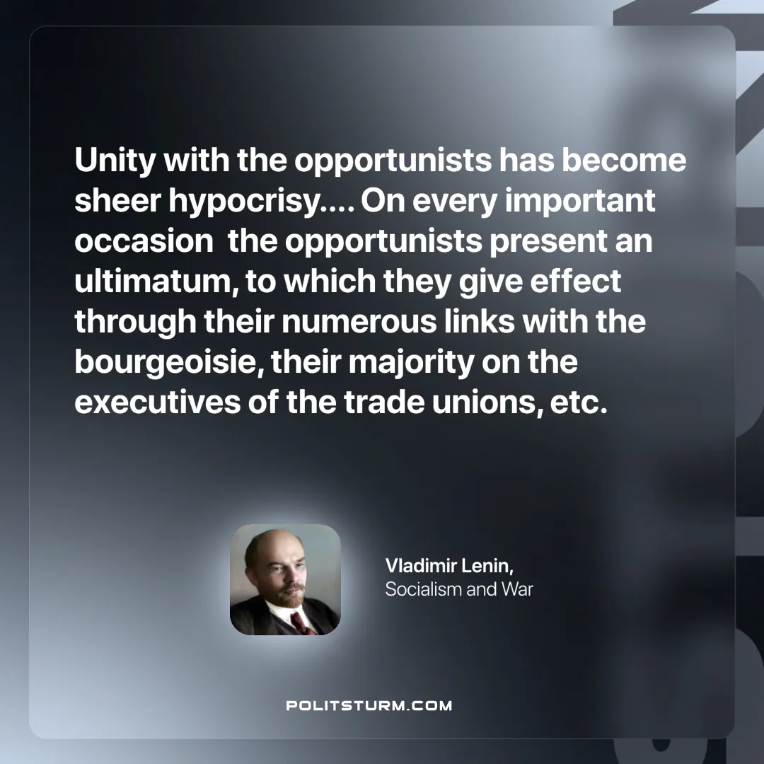

Original article
2025-05-01

Unity with the opportunists has become sheer hypocrisy…. On every important occasion the opportunists present an ultimatum, to which they give effect through their numerous links with the bourgeoisie, their majority on the executives of the trade unions, etc.”
Vladimir Lenin, Socialism and War

Original article

