Lenin on 'Unity' With Opportunists
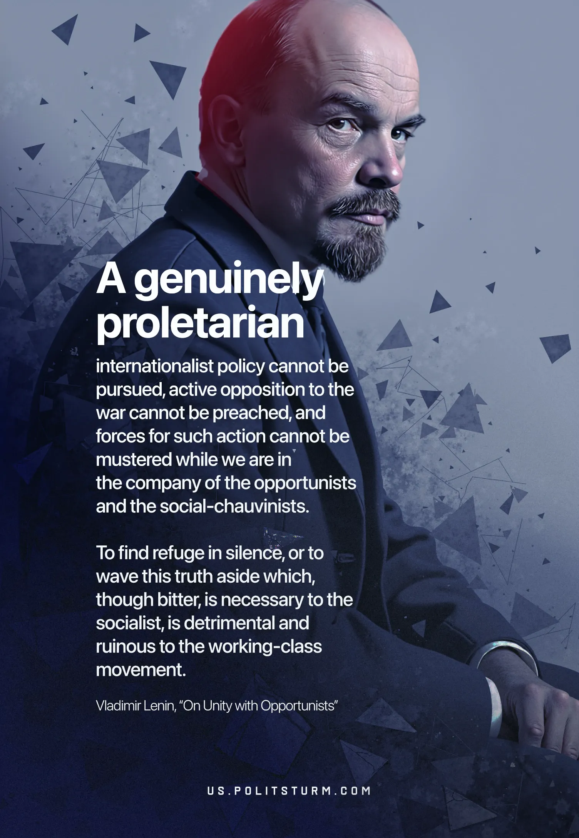

Original article
2025-04-22

155 years ago, on April 22, 1870, Vladimir Ilyich Lenin was born. He was the leader of the world proletariat, the founder of the Soviet state, a revolutionary and the great theorist of Marxism.
Lenin's example teaches communists to fight uncompromisingly against various deviations. This struggle is more relevant today than ever.

Original article

