Lenin on Unity of the Communist Workers
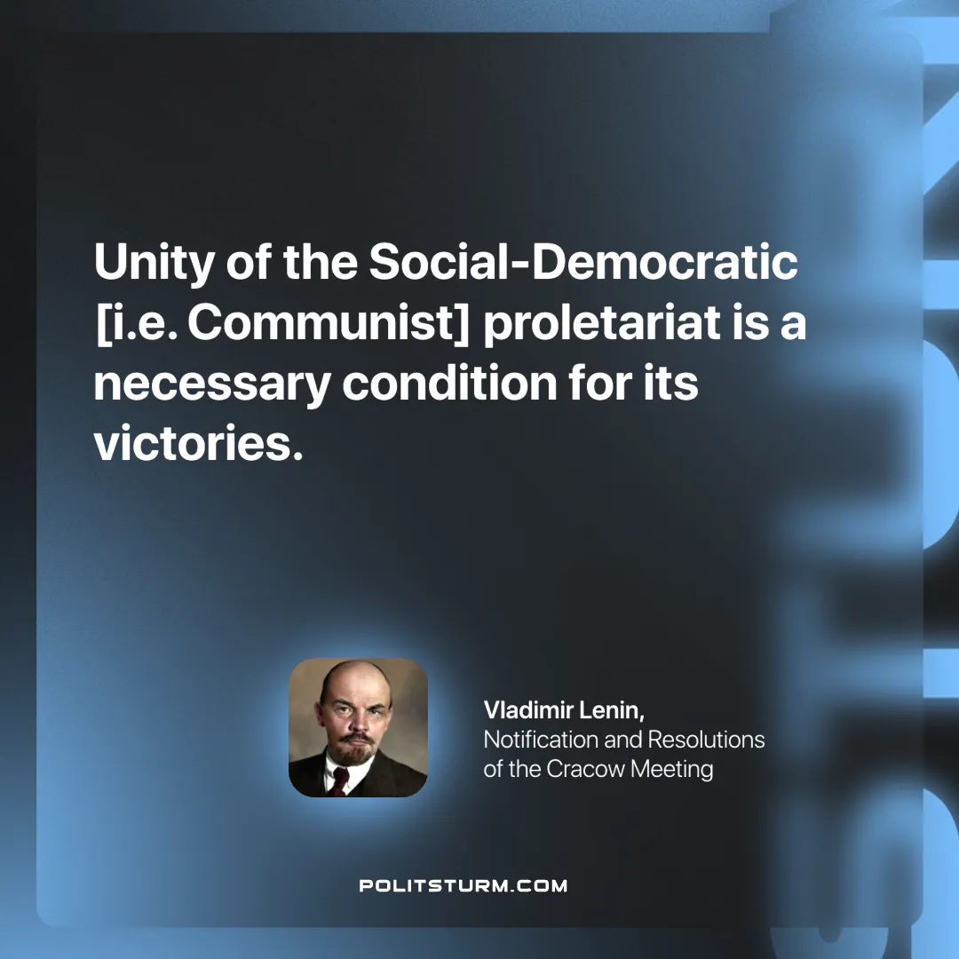

Original article
2025-03-01

"Unity of the Social-Democratic [i.e. Communist] proletariat is a necessary condition for its victories."
Vladimir Lenin, Notification and Resolutions of the Cracow Meeting

Original article

