Lenin on Unity
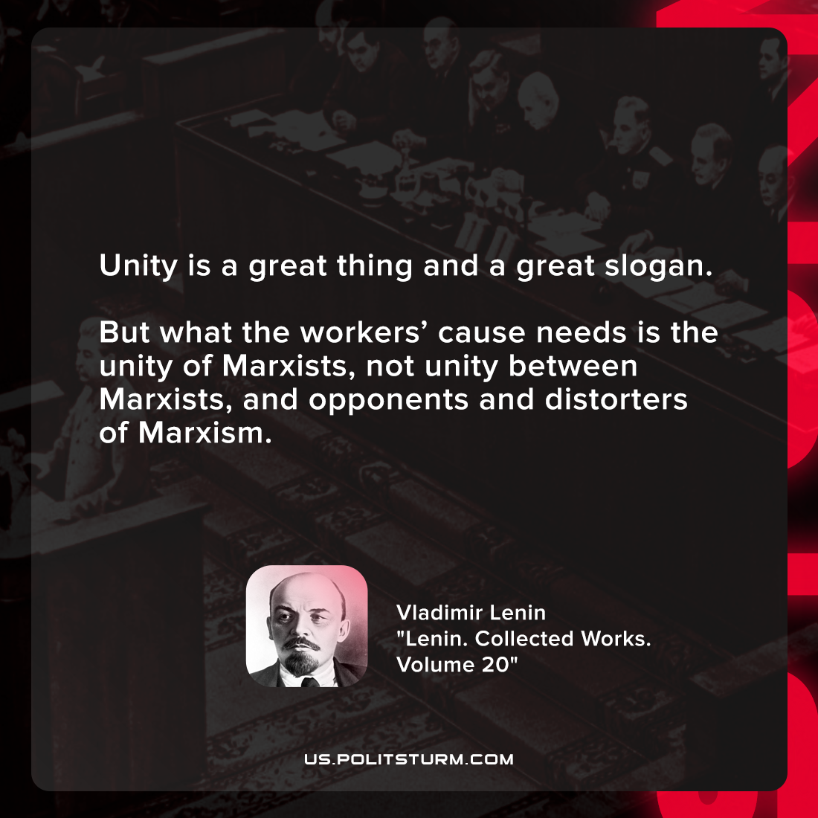

Original article
2022-01-11

Unity is a great thing and a great slogan. But what the workers’ cause needs is the unity of Marxists, not unity between Marxists, and opponents and distorters of Marxism.

Vladimir Lenin, “Lenin. Collected Works. Volume 20”

Original article

