Lenin on Trotsky's Original Theory
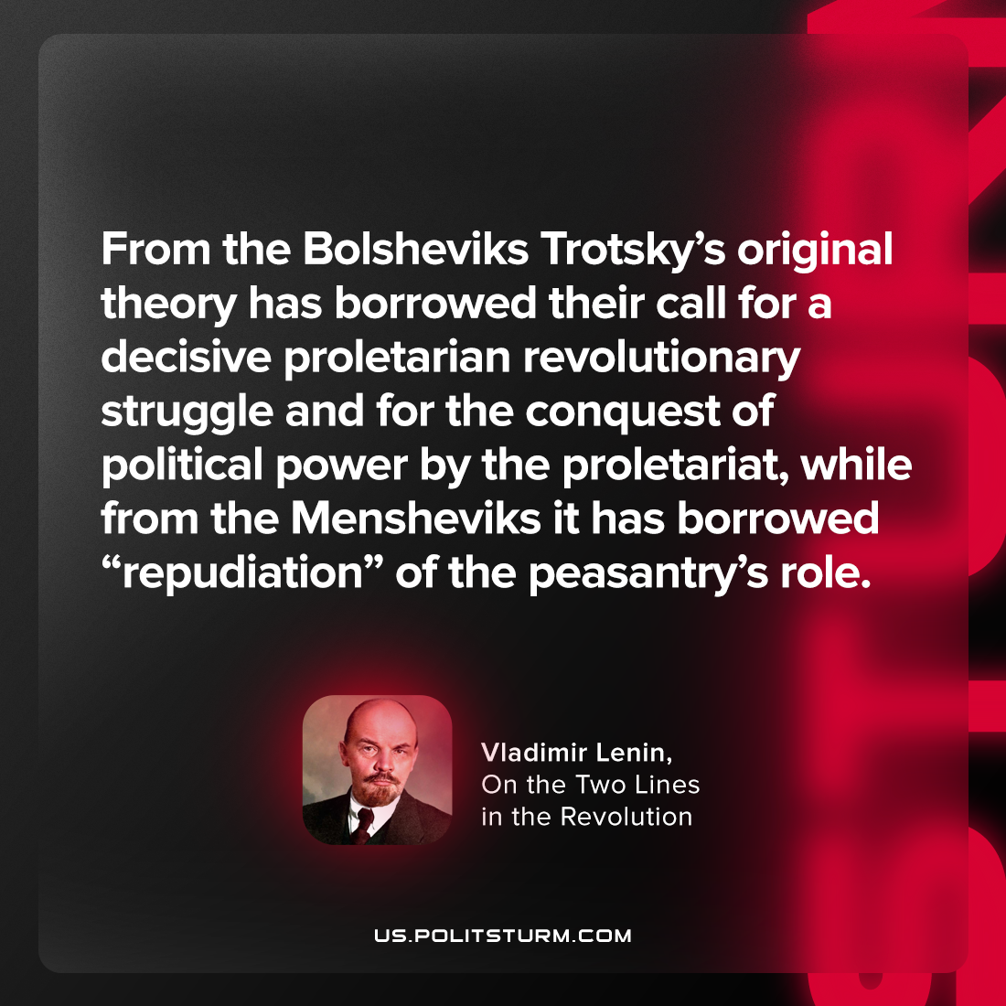

Original article
2023-07-08

"From the Bolsheviks Trotsky’s original theory has borrowed their call for a decisive proletarian revolutionary struggle and for the conquest of political power by the proletariat, while from the Mensheviks it has borrowed “repudiation” of the peasantry’s role."
Vladimir Lenin, On the Two Lines in the Revolution

Original article

