Lenin on Trotsky's Theory of Repudiation of the Role of the Peasantry
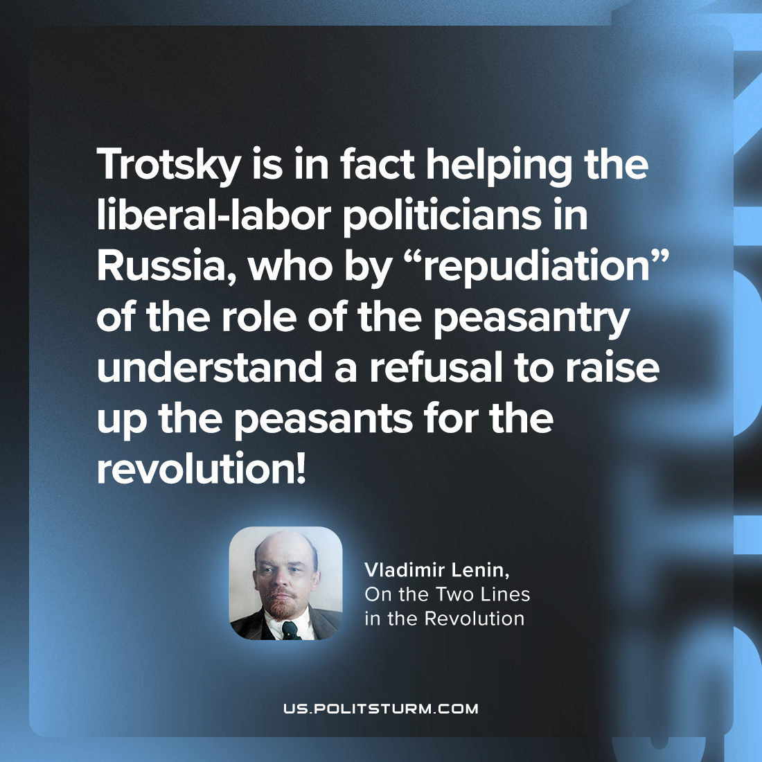

Original article
2023-08-10

"Trotsky is in fact helping the liberal-labor politicians in Russia, who by “repudiation” of the role of the peasantry understand a refusal to raise up the peasants for the revolution!"
Vladimir Lenin, On the Two Lines in the Revolution

Original article

