Lenin on Marxist Theoretical and Historical analysis
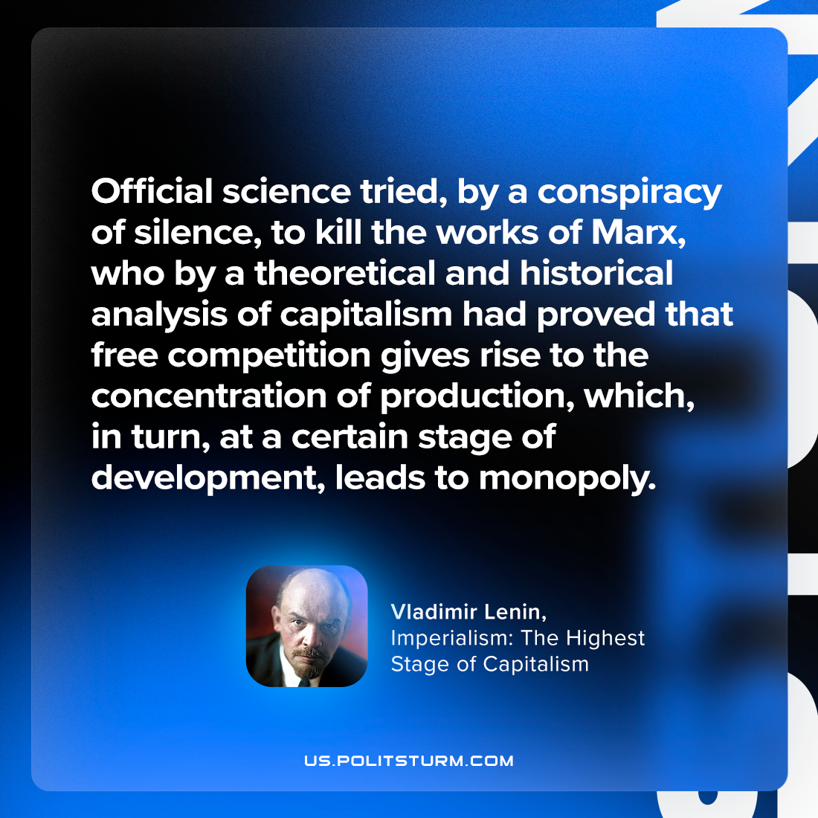

Original article
2023-08-27

"Official science tried, by a conspiracy of silence, to kill the works of Marx, who by a theoretical and historical analysis of capitalism had proved that free competition gives rise to the concentration of production, which, in turn, at a certain stage of development, leads to monopoly."
Vladimir Lenin, Imperialism: the Highest Stage of Capitalism

Original article

