Lenin on the Workers' Movement
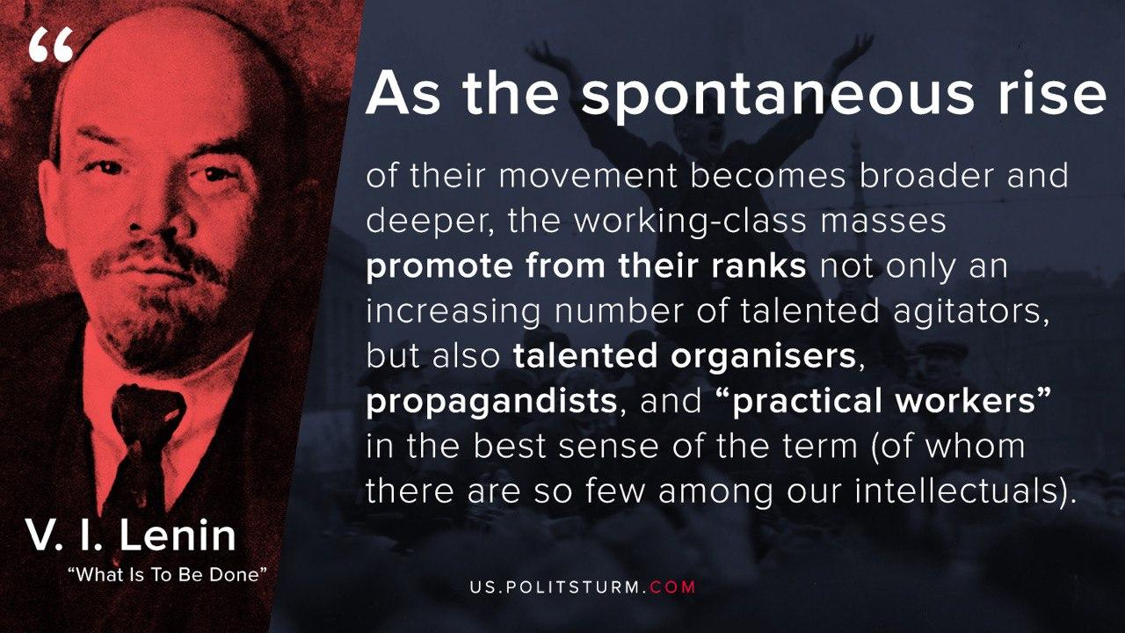

Original article
2020-05-19

As the spontaneous rise of their movement becomes broader and deeper, the working-class masses promote from their ranks not only an increasing number of talented agitators, but also talented organisers, propagandists, and “practical workers” in the best sense of the term (of whom there are so few among our intellectuals who, for the most part, in the Russian manner, are somewhat careless and sluggish in their habits).
Vladimir Ilyich Lenin
What Is To Be Done?

Original article

