Lenin on the Workers' Class-Consciousness
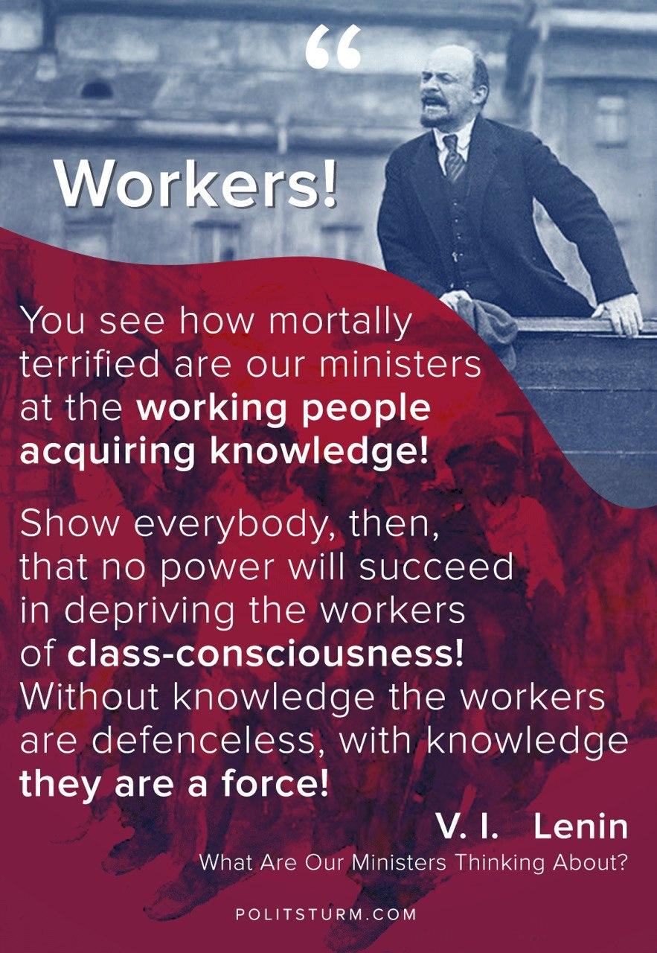

Original article
2020-05-05

Workers! You see how mortally terrified are our ministers at the working people acquiring knowledge! Show everybody, then, that no power will succeed in depriving the workers of class-consciousness! Without knowledge the workers are defenceless, with knowledge they are a force!
V. I. Lenin, “What Are Our Ministers Thinking About?”

Original article

