Lenin on the Vagueness of Opportunism
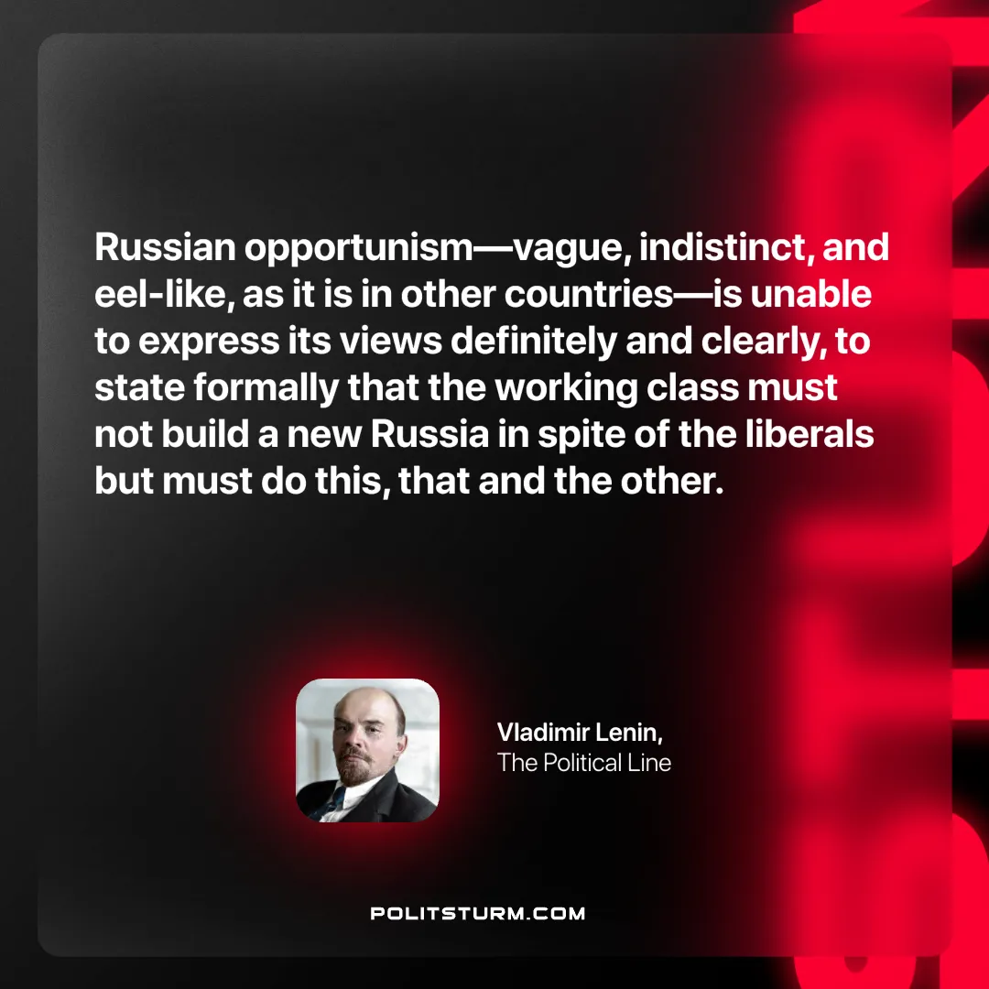

Original article
2025-03-11

"Russian opportunism—vague, indistinct, and eel-like, as it is in other countries—is unable to express its views definitely and clearly, to state formally that the working class must not build a new Russia in spite of the liberals but must do this, that and the other.”
Vladimir Lenin, The Political Line

Original article

