Lenin on Rallying Marxists
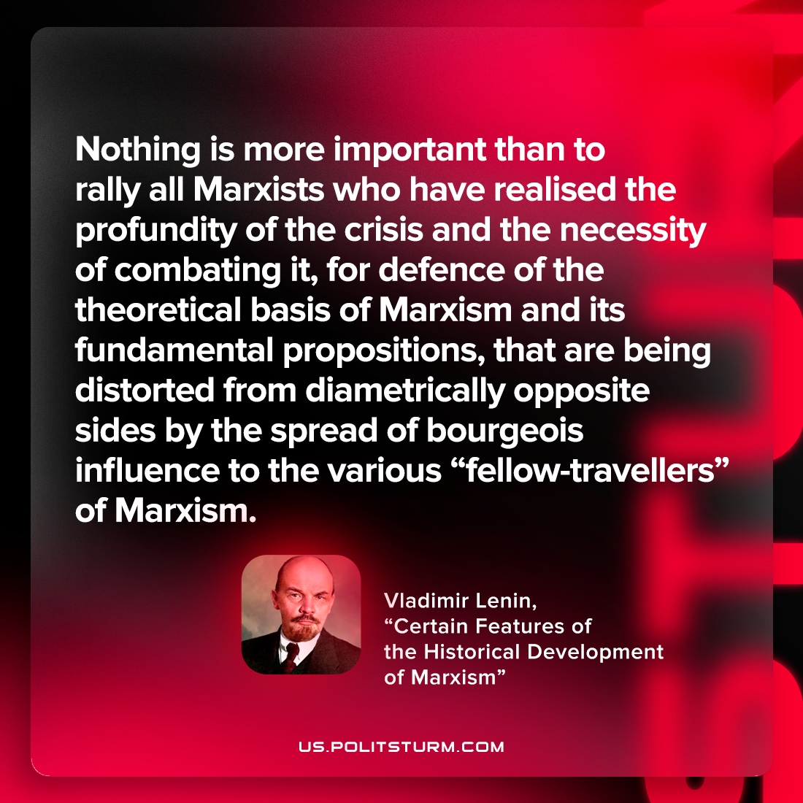

Original article
2022-10-18

Nothing is more important than to rally all Marxists who have realised the profundity of the crisis and the necessity of combating it, for defence of the theoretical basis of Marxism and its fundamental propositions, that are being distorted from diametrically opposite sides by the spread of bourgeois influence to the various “fellow-travellers” of Marxism.

Vladimir Lenin, “Certain Features of the Historical Development of Marxism”

Original article

