Lenin on the Transition Towards Communism
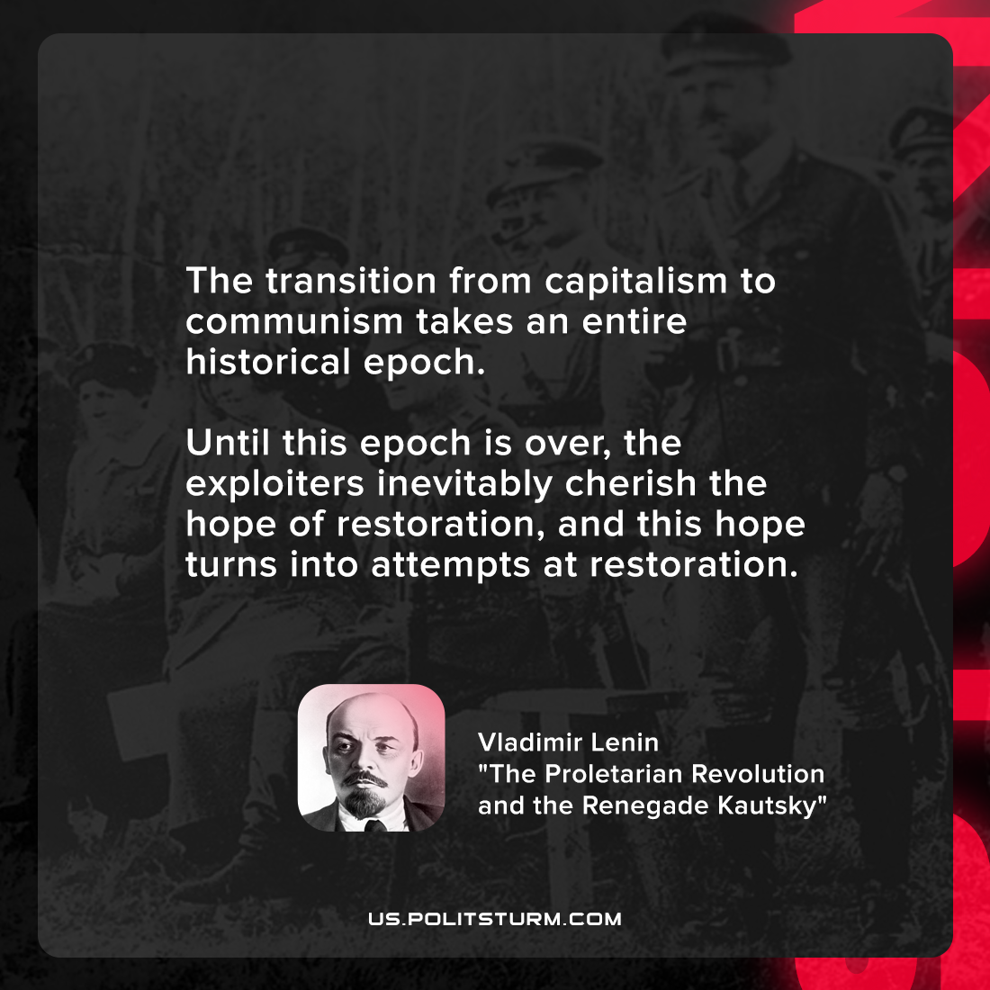

Original article
2022-03-06

The transition from capitalism to communism takes an entire historical epoch. Until this epoch is over, the exploiters inevitably cherish the hope of restoration, and this hope turns into attempts at restoration.

Vladimir Lenin, “The Proletarian Revolution and the Renegade Kautsky”

Original article

