Lenin on the Transition to Socialism
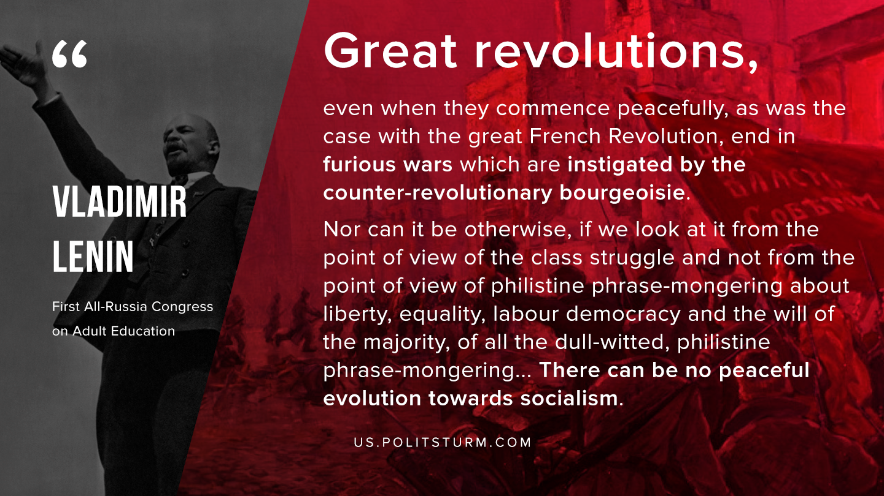

Original article
2019-11-14
1 min read

Great revolutions, even when they commence peacefully, as was the case with the great French Revolution, end in furious wars which are instigated by the counter-revolutionary bourgeoisie. Nor can it be otherwise, if we look at it from the point of view of the class struggle and not from the point of view of philistine phrase-mongering about liberty, equality, labour democracy and the will of the majority, of all the dull-witted, philistine phrase-mongering… There can be no peaceful evolution towards socialism.
V.I. Lenin, “First All-Russia Congress on Adult Education”

Original article

