Lenin on the Third Way
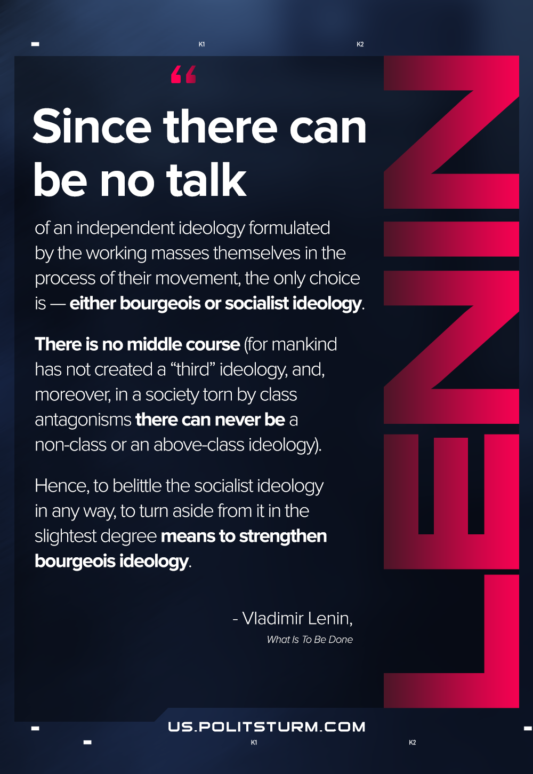

Original article
2021-03-27
1 min read

Since there can be no talk of an independent ideology formulated by the working masses themselves in the process of their movement, the only choice is — either bourgeois or socialist ideology. There is no middle course (for mankind has not created a “third” ideology, and, moreover, in a society torn by class antagonisms there can never be a non-class or an above-class ideology). Hence, to belittle the socialist ideology in any way, to turn aside from it in the slightest degree means to strengthen bourgeois ideology.
What Is To Be Done

Original article

