Lenin on the Task of Revolutionaries to End Faith in Opportunists
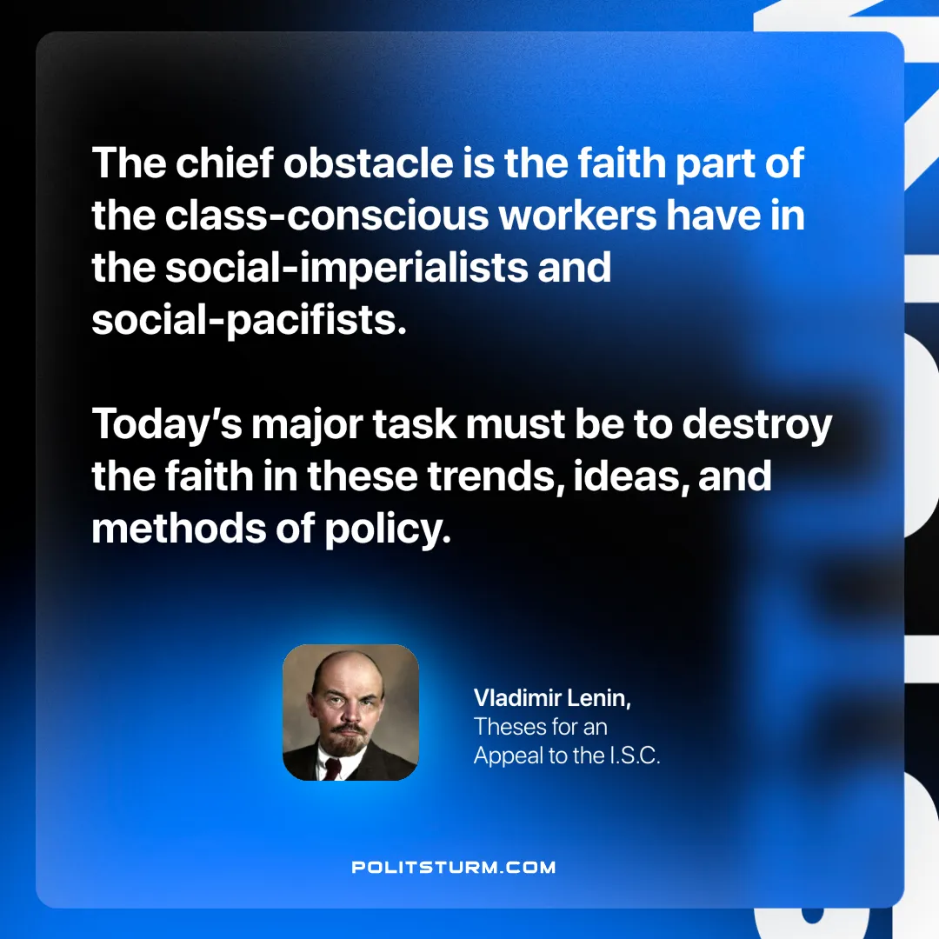

Original article
2025-06-21

“The chief obstacle is the faith part of the class-conscious workers have in the social-imperialists and social-pacifists. Today’s major task must be to destroy the faith in these trends, ideas, methods of policy.”
Vladimir Lenin,Theses for an Appeal to the I.S.C.

Original article

