Lenin on the Struggle in Every Country
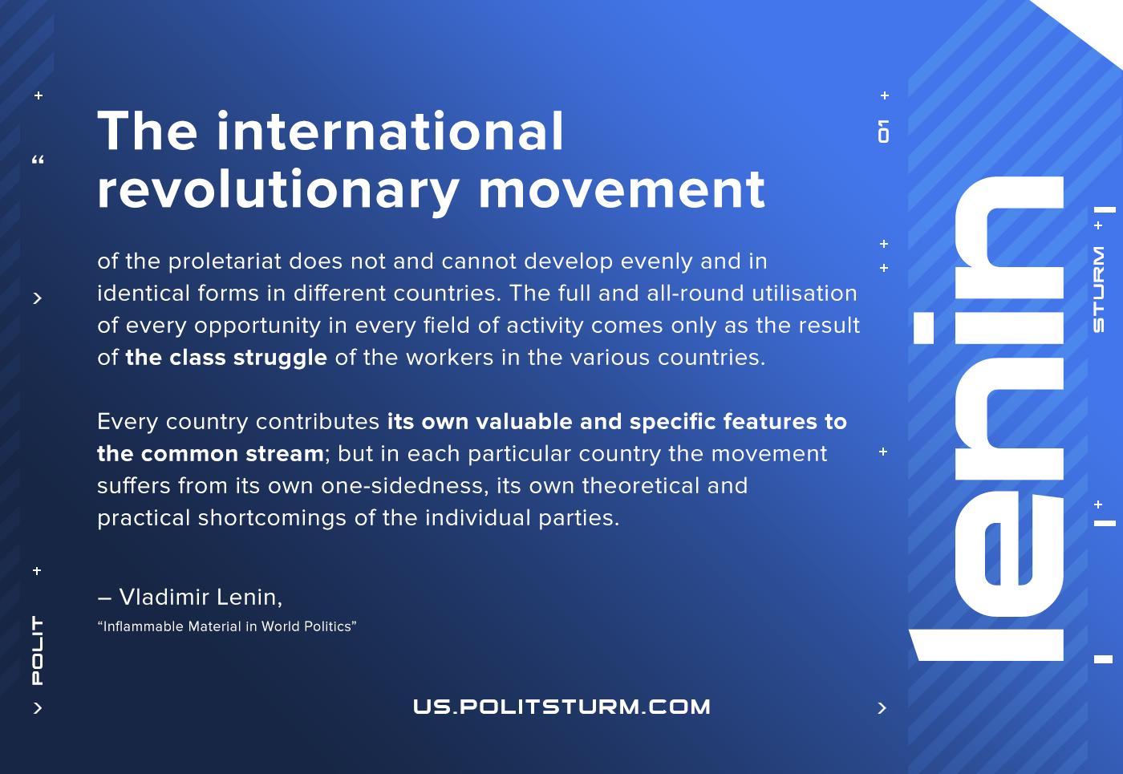

Original article
2021-06-01
1 min read

The international revolutionary movement of the proletariat does not and cannot develop evenly and in identical forms in different countries. The full and all-round utilisation of every opportunity in every field of activity comes only as the result of the class struggle of the workers in the various countries.
Every country contributes its own valuable and specific features to the common stream; but in each particular country the movement suffers from its own one-sidedness, its own theoretical and practical shortcomings of the individual parties.
– Vladimir Lenin, Inflammable Material in World Politics

Original article

