Lenin on the Struggle Against Opportunism and Imperialism
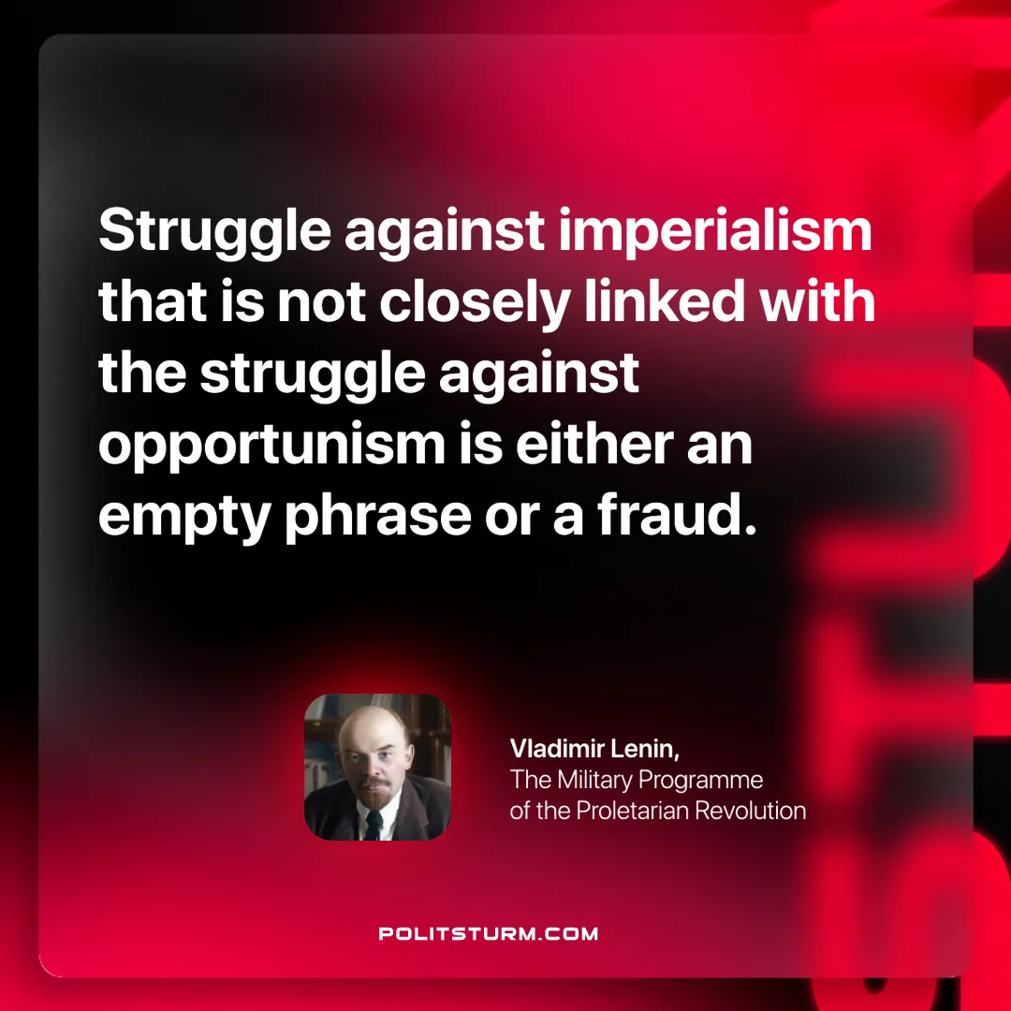

Original article
2025-06-01

“Struggle against imperialism that is not closely linked with the struggle against opportunism is either an empty phrase or a fraud.”
Vladimir Lenin, The Military Programme of the Proletarian Revolution

Original article

