Lenin on the Struggle Against Opportunism
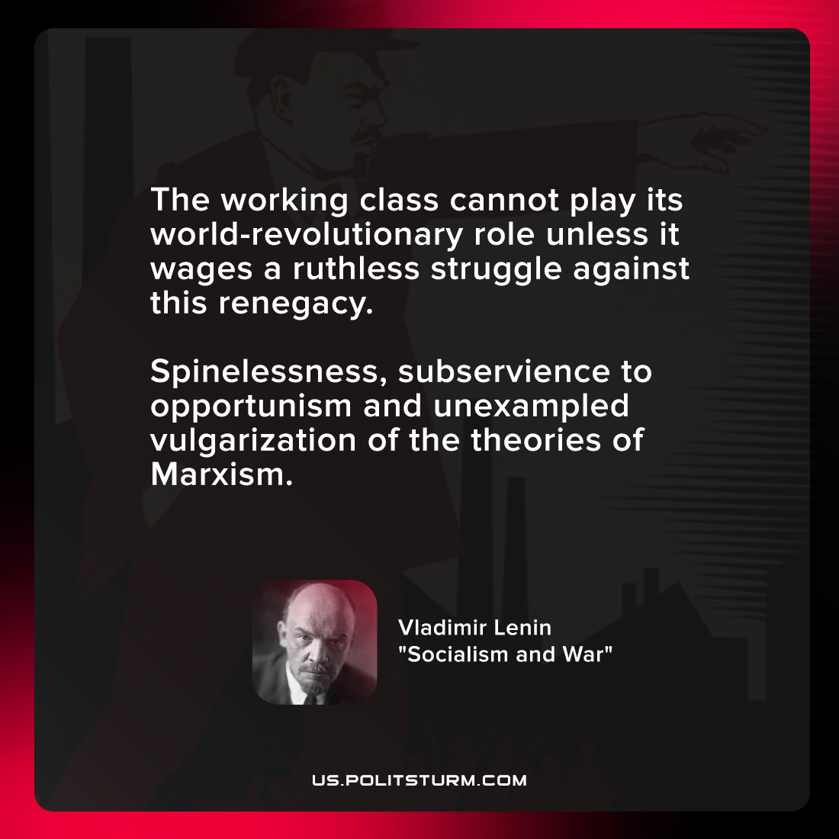

Original article
2021-12-14

The working class cannot play its world-revolutionary role unless it wages a ruthless struggle against this renegacy. spinelessness, subservience to opportunism and unexampled vulgarization of the theories of Marxism.

Vladimir Lenin, “Socialism and War”

Original article

