Lenin on the Struggle Against Bourgeois Nationalism
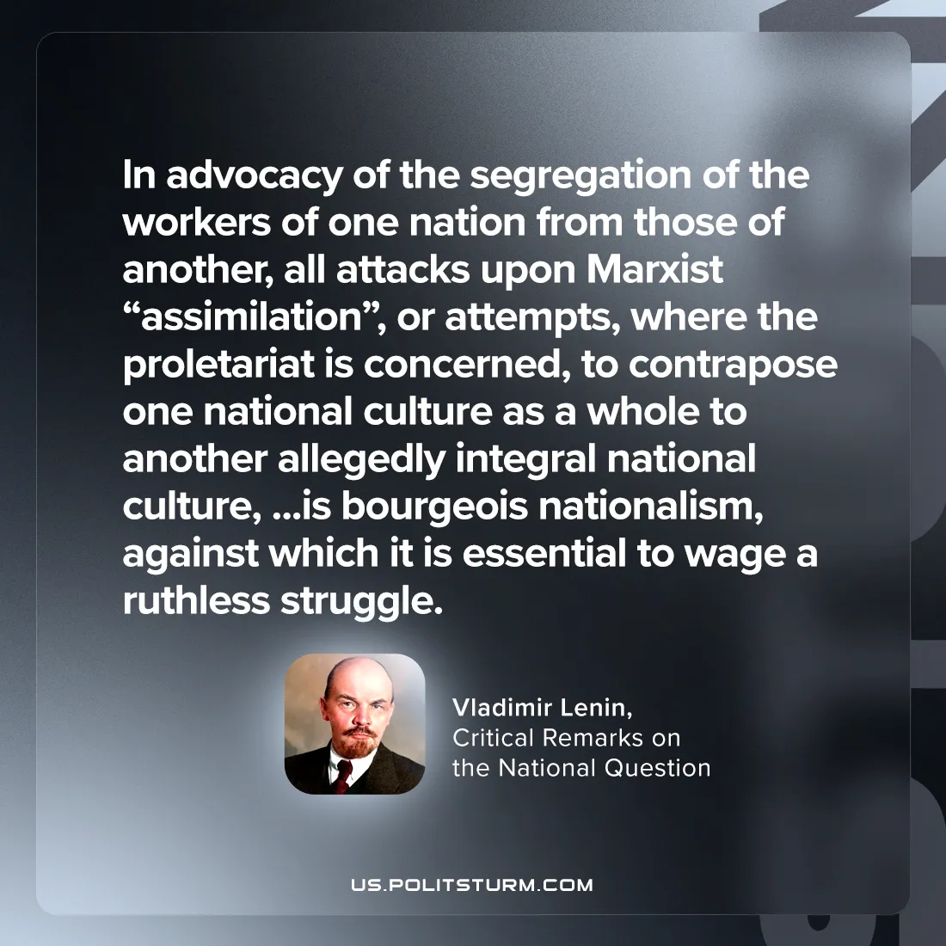

Original article
2024-08-04

"ln advocacy of the segregation of the workers of one nation from those of another, all attacks upon Marxist “assimilation”, or attempts, where the proletariat is concerned, to contrapose one national culture as a whole to another allegedly integral national culture, and so forth, is bourgeois nationalism, against which it is essential to wage a ruthless struggle.”
Vladimir Lenin, Critical Remarks on the National Question

Original article

