Lenin on the Soviet influence
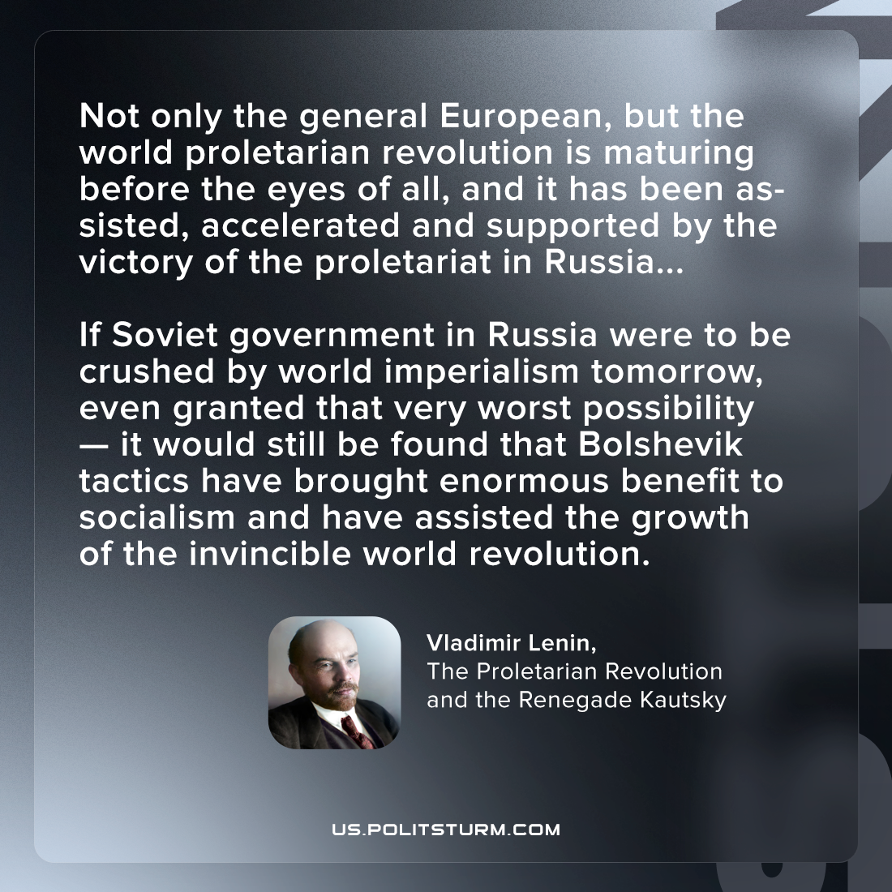

Original article
2022-12-30
1 min read

"Not only the general European, but the world proletarian revolution is maturing before the eyes of all, and it has been assisted, accelerated and supported by the victory of the proletariat in Russia. All this is not enough for the complete victory of socialism, you say? Of course it is not enough. One country alone cannot do more. But this one country, thanks to Soviet government, has done so much that even if Soviet government in Russia were to be crushed by world imperialism tomorrow, as a result, let us say, of an agreement between German and Anglo-French imperialism — even granted that very worst possibility — it would still be found that Bolshevik tactics have brought enormous benefit to socialism and have assisted the growth of the invincible world revolution." – Vladimir Lenin, "The Proletarian Revolution and the Renegade Kautsky"

Original article

