Lenin on the Soviet Foreign Policy
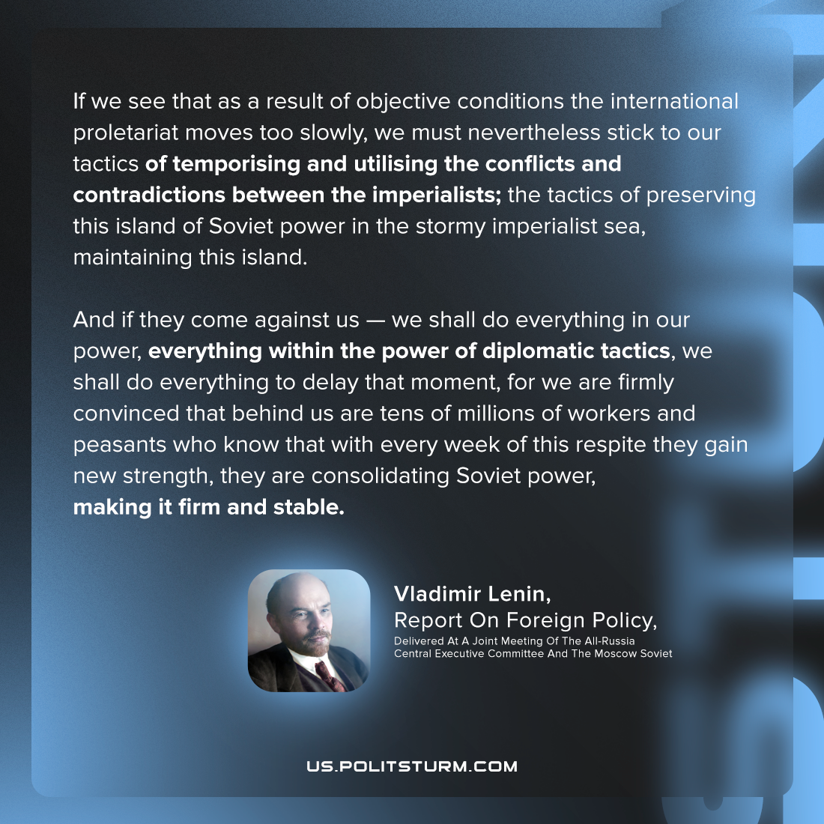

Original article
2022-09-01
2 min read

Any person who does not shut his eyes to the facts, who is not blind, knows that we are merely repeating what we have said earlier, and what we have always said: that we do not forget the weakness of the Russian working class compared to other contingents of the international proletariat.
It was not our own will, but historical circumstances, the legacy of the tsarist regime, the flabbiness of the Russian bourgeoisie, that caused this contingent to march ahead of the other contingents of the international proletariat; it was not because we desired it, but because circumstances demanded it. We must remain at our post until the arrival of our ally, the international proletariat, which will arrive and will inevitably arrive, but which is approaching at an immeasurably slower pace than we expect or wish.
If we see that as a result of objective conditions the international proletariat moves too slowly, we must nevertheless stick to our tactics of temporising and utilising the conflicts and contradictions between the imperialists, of slowly accumulating strength; the tactics of preserving this island of Soviet power in the stormy imperialist sea, maintaining this island which now already attracts the gaze of the working people of all countries. That is why we tell ourselves that, if the extremist war party can at any moment defeat any imperialist coalition and build a new unexpected imperialist coalition against us, we at any rate will not make it any easier for them.
And if they come against us — yes, we are now defencists — we shall do everything in our power, everything within the power of diplomatic tactics, we shall do everything to delay that moment, everything to make the brief and unstable respite, given us in March, last longer, for we are firmly convinced that behind us are tens of millions of workers and peasants who know that with every week and, even more so, with every month of this respite they gain new strength, they are consolidating Soviet power, making it firm and stable. They know that they are introducing a new spirit, and that after the attrition and weariness of this exhausting reactionary war, they will create firmness and readiness for the last and decisive battle should external forces attack the Socialist Soviet Republic.
Vladimir Lenin, Report On Foreign Policy Delivered At A Joint Meeting Of The All-Russia Central Executive Committee And The Moscow Soviet. May 14, 1918.

Original article

