Lenin on the Solution to the National Question
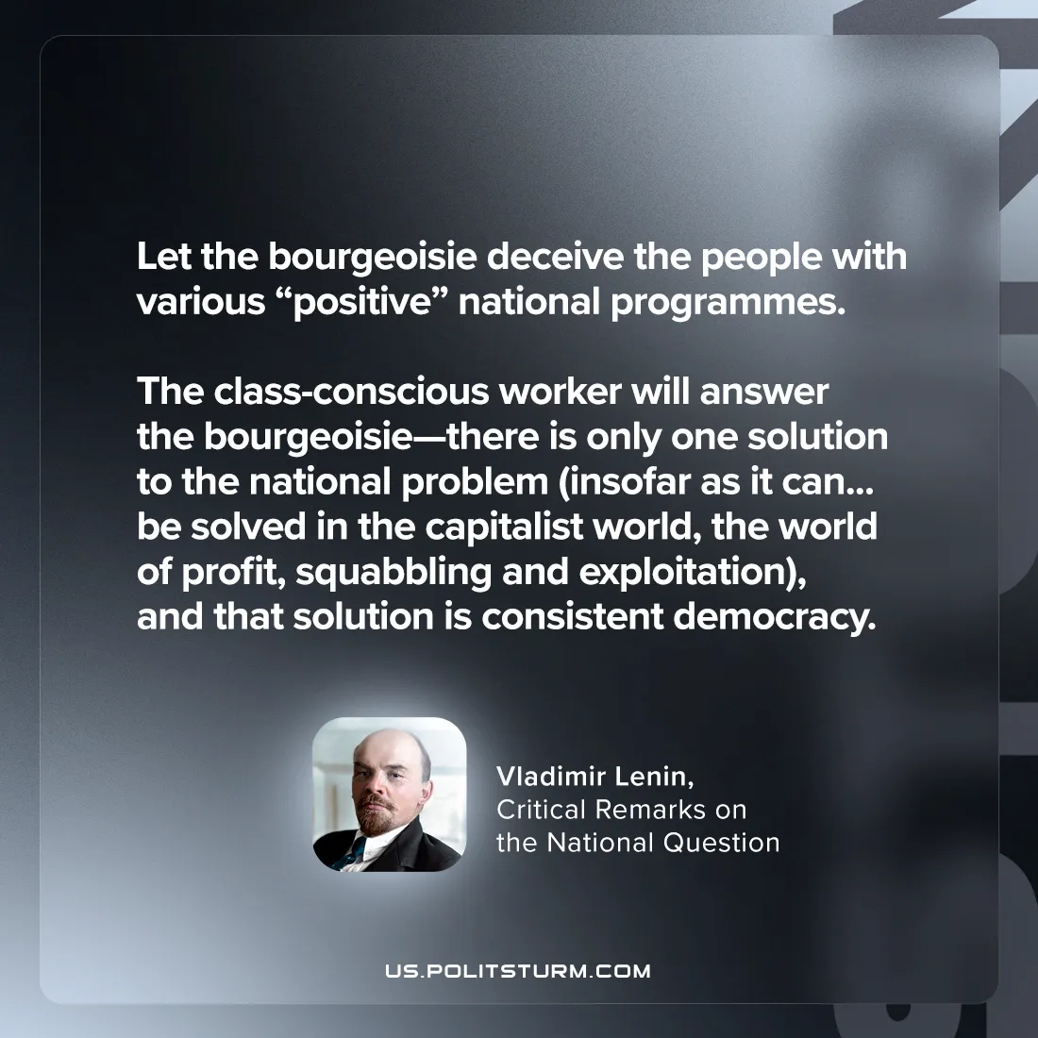

Original article
2024-07-21

"Let the bourgeoisie deceive the people with various “positive” national programmes. The class-conscious worker will answer the bourgeoisie—there is only one solution to the national problem (insofar as it can, in general, be solved in the capitalist world, the world of profit, squabbling and exploitation), and that solution is consistent democracy.”
Vladimir Lenin, Critical Remarks on the National Question

Original article

