Lenin on the Socialist Revolution as a Process
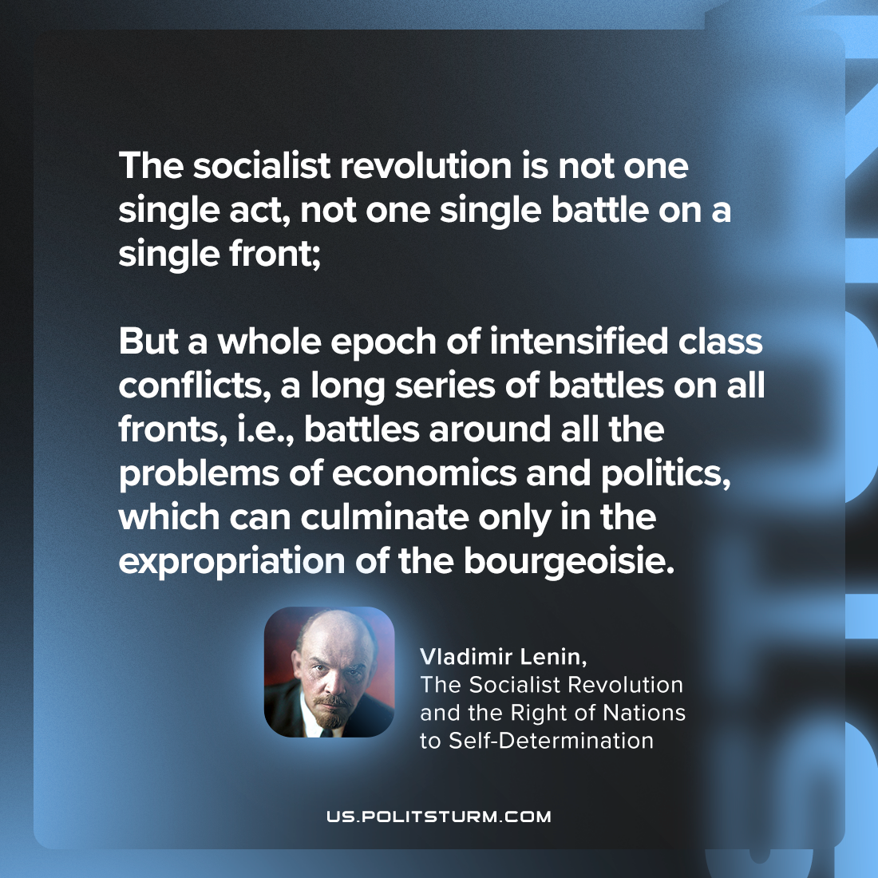

Original article
2024-03-28

“The socialist revolution is not one single act, not one single battle on a single front; but a whole epoch of intensified class conflicts, a long series of battles on all fronts, i.e., battles around all the problems of economics and politics, which can culminate only in the expropriation of the bourgeoisie.”
Vladimir Lenin, The Socialist Revolution and the Right of Nations to Self-Determination

Original article

