Lenin on the Revolutionary Situation
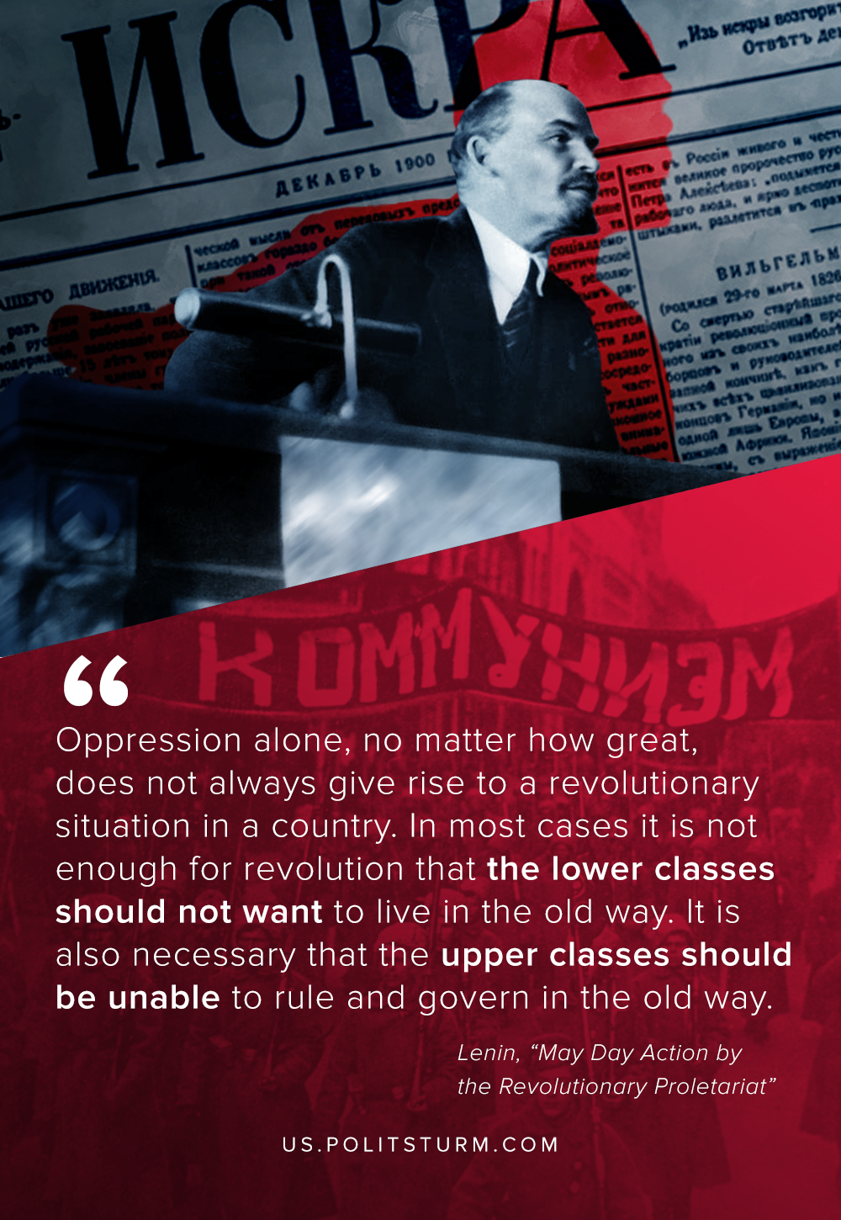

Original article
2020-06-02

Oppression alone, no matter how great, does not always give rise to a revolutionary situation in a country.
In most cases it is not enough for revolution that the lower classes should not want to live in the old way. It is also necessary that the upper classes should be unable to rule and govern in the old way.
Vladimir Lenin, May Day Action by the Revolutionary Proletariat

Original article

