Lenin on the Revolutionary Class
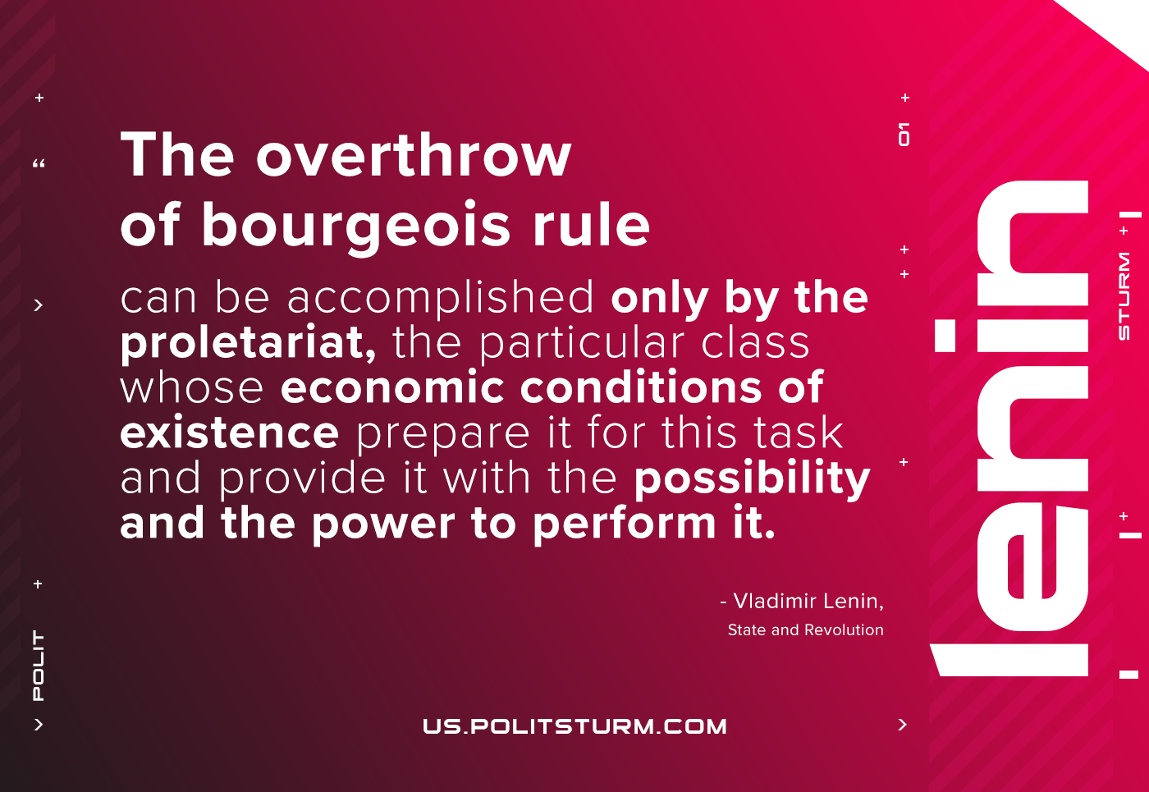

Original article
2021-05-25

The overthrow of bourgeois rule can be accomplished only by the proletariat, the particular class whose economic conditions of existence prepare it for this task and provide it with the possibility and the power to perform it.
Lenin, State and Revolution

Original article

