Lenin on the Reply of the Proletariat
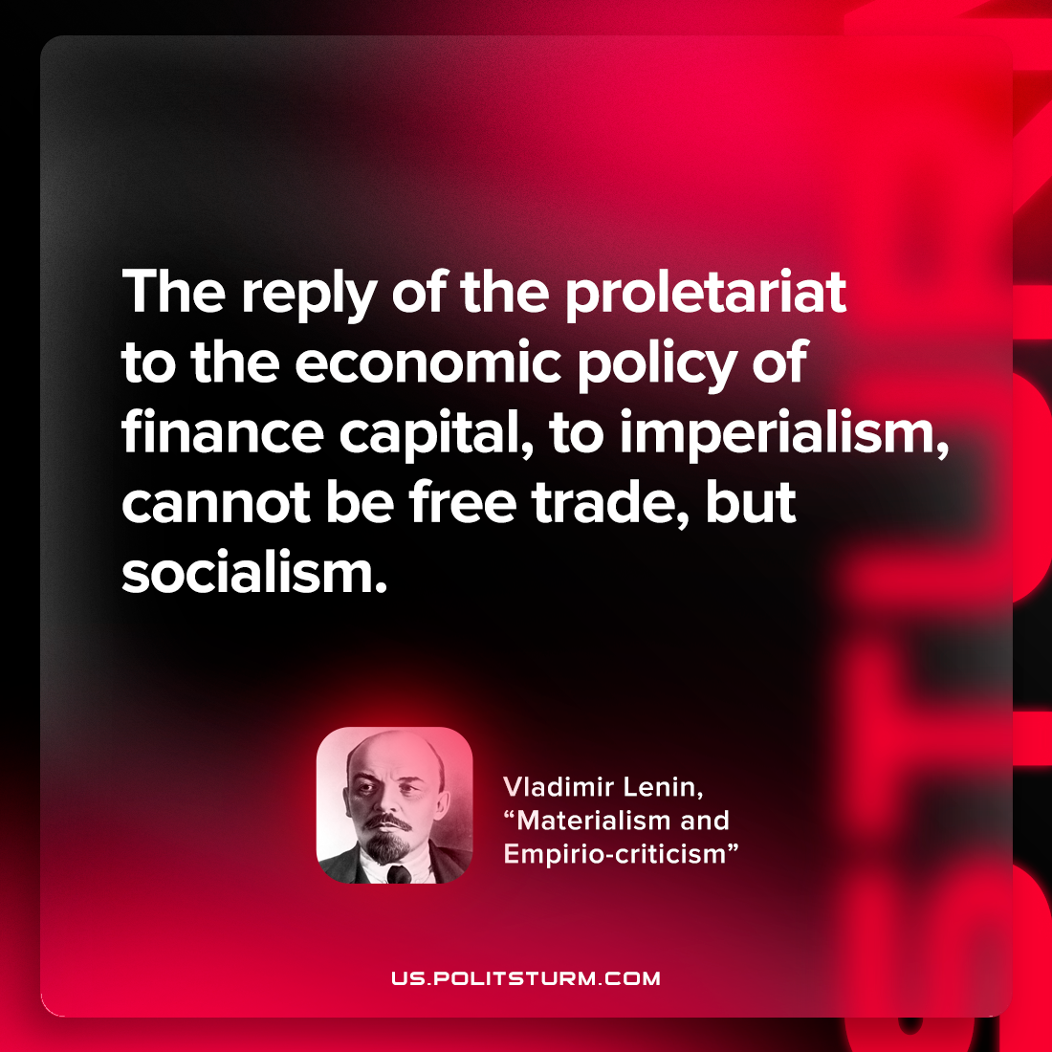

Original article
2022-08-04

The reply of the proletariat to the economic policy of finance capital, to imperialism, cannot be free trade, but socialism.

Vladimir Lenin, “Materialism and empirio-criticism”

Original article

