Lenin on the Reflection of Religion in Society
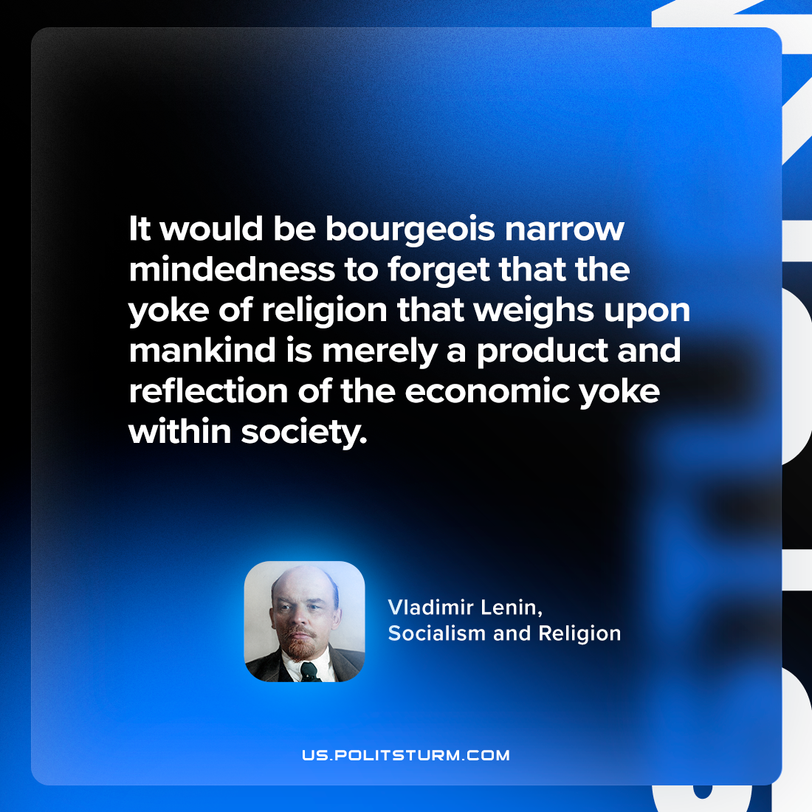

Original article
2024-05-23

"It would be bourgeois narrow-mindedness to forget that the yoke of religion that weighs upon mankind is merely a product and reflection of the economic yoke within society."
Vladimir Lenin, Socialism and Religion

Original article

