Lenin on the Proletariat Being at Odds with Capitalist Policy
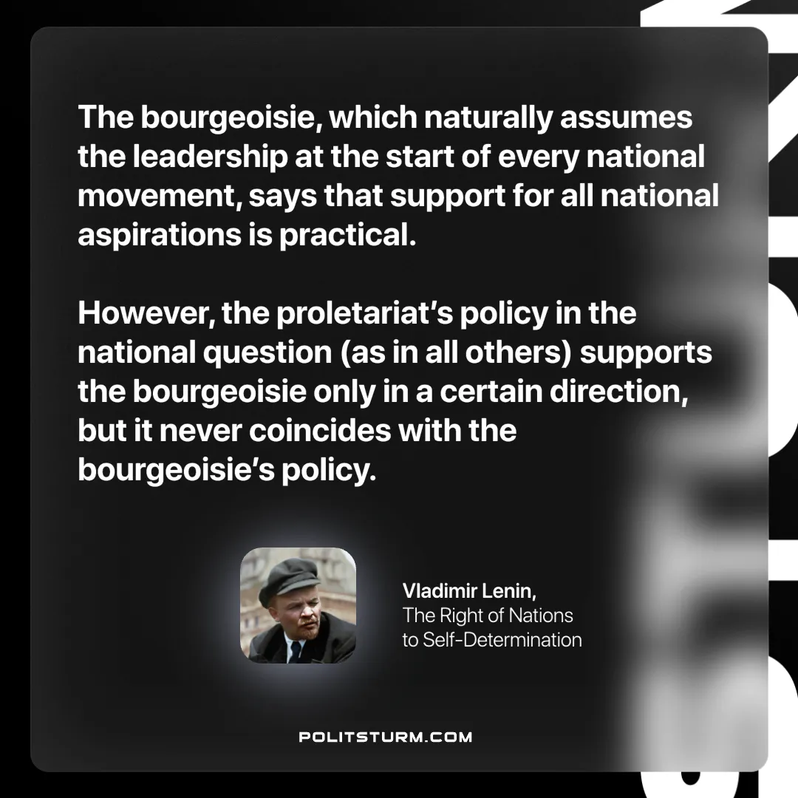

Original article
2025-02-16

“The bourgeoisie, which naturally assumes the leadership at the start of every national movement, says that support for all national aspirations is practical. However, the proletariat’s policy in the national question (as in all others) supports the bourgeoisie only in a certain direction, but it never coincides with the bourgeoisie’s policy.”
Vladimir Lenin, The Right of Nations to Self-determination

Original article

