Lenin on the Proletarian Rule
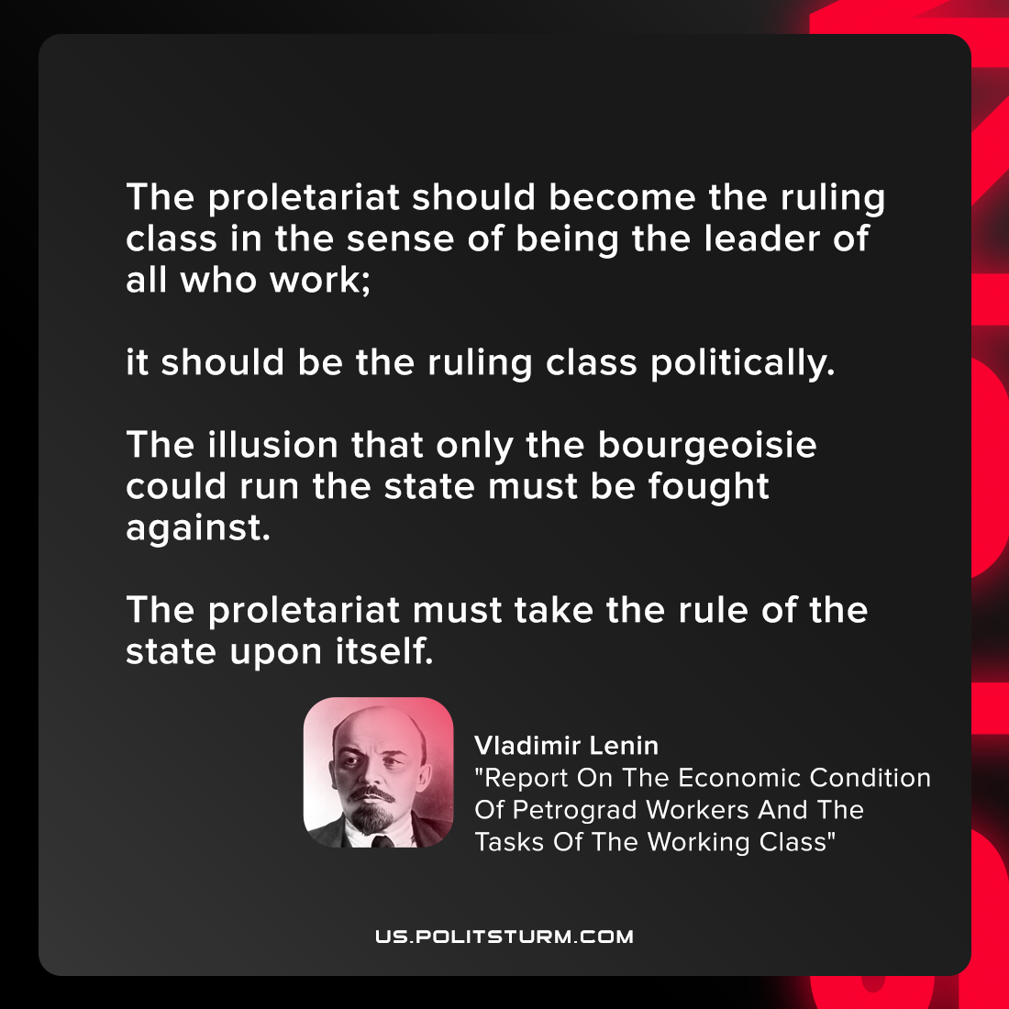

Original article
2021-09-29

The proletariat should become the ruling class in the sense of being the leader of all who work; it should be the ruling class politically. The illusion that only the bourgeoisie could run the state must be fought against. The proletariat must take the rule of the state upon itself.

Vladimir Lenin, “Report On The Economic Condition Of Petrograd Workers And The Tasks Of The Working Class”

Original article

