Lenin on the Proletarian Dictatorship
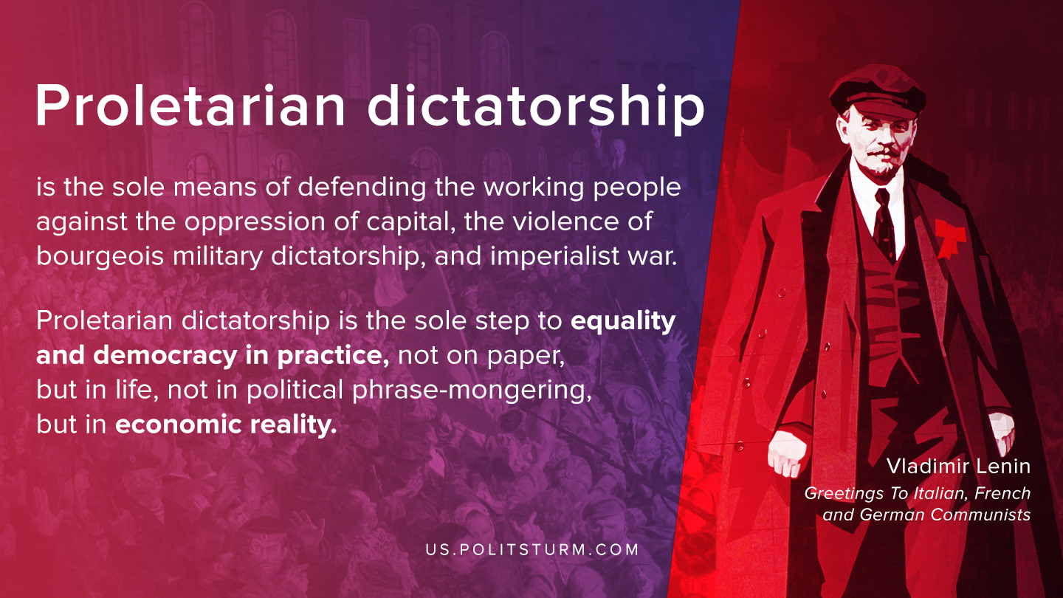

Original article
2020-09-14

Proletarian dictatorship is the sole means of defending the working people against the oppression of capital, the violence of bourgeois military dictatorship, and imperialist war.
Proletarian dictatorship is the sole step to equality and democracy in practice, not on paper, but in life, not in political phrase-mongering, but in economic reality.
Vladimir Lenin, Greetings To Italian, French and German Communists

Original article

