Lenin on the Profits of Financial Capital in a Crisis
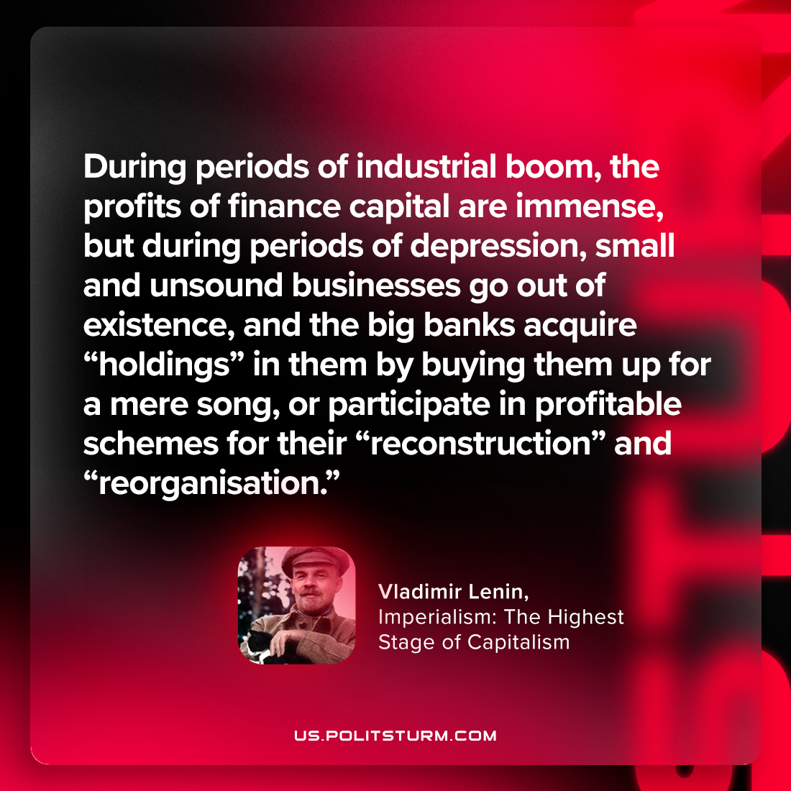

Original article
2023-10-19

"During periods of industrial boom, the profits of finance capital are immense, but during periods of depression, small and unsound businesses go out of existence, and the big banks acquire “holdings” in them by buying them up for a mere song, or participate in profitable schemes for their “reconstruction” and “reorganisation.”"
Vladimir Lenin, Imperialism: the Highest Stage of Capitalism

Original article

