Lenin on the Power of the Majority
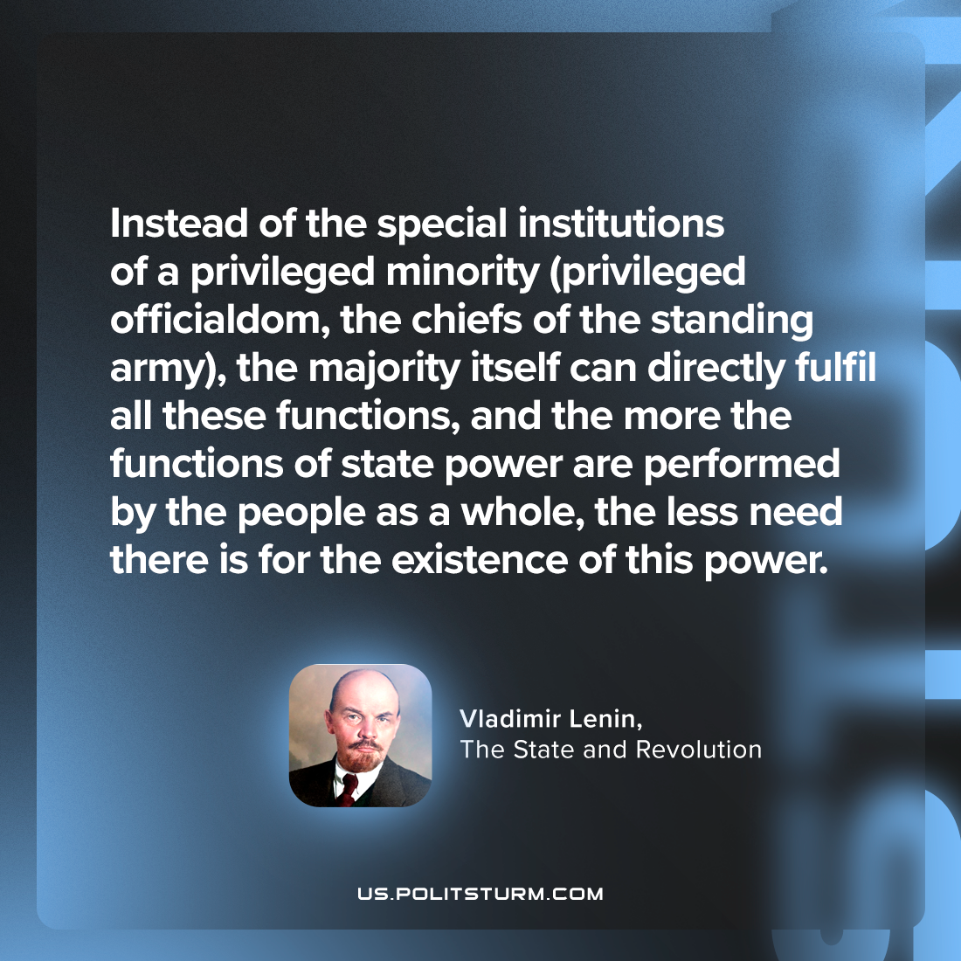

Original article
2024-03-03

"Instead of the special institutions of a privileged minority (privileged officialdom, the chiefs of the standing army), the majority itself can directly fulfil all these functions, and the more the functions of state power are performed by the people as a whole, the less need there is for the existence of this power."
Vladimir Lenin, The State and Revolution

Original article

