Lenin on the Power Increase of Financial Oligarchy
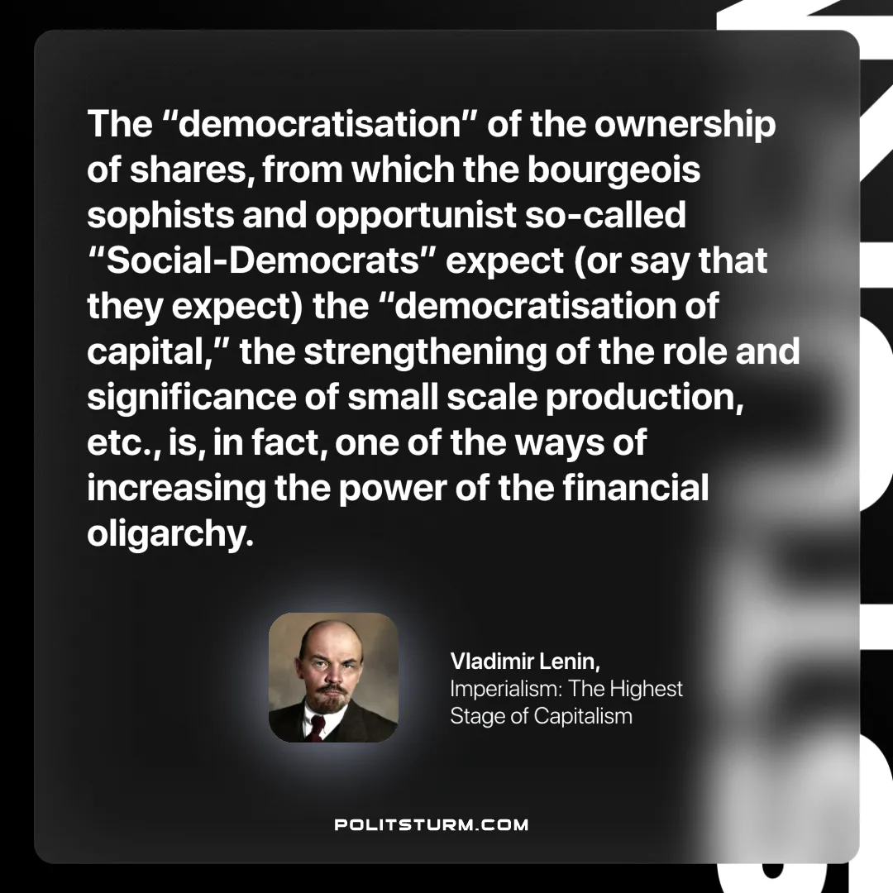

Original article
2024-11-26

“The “democratisation” of the ownership of shares, from which the bourgeois sophists and opportunist so-called “Social-Democrats” expect (or say that they expect) the “democratisation of capital,” the strengthening of the role and significance of small scale production, etc., is, in fact, one of the ways of increasing the power of the financial oligarchy.”
Vladimir Lenin, Imperialism: The Highest Stage of Capitalism

Original article

