Lenin on the Political Liberty of Workers and Capitalism
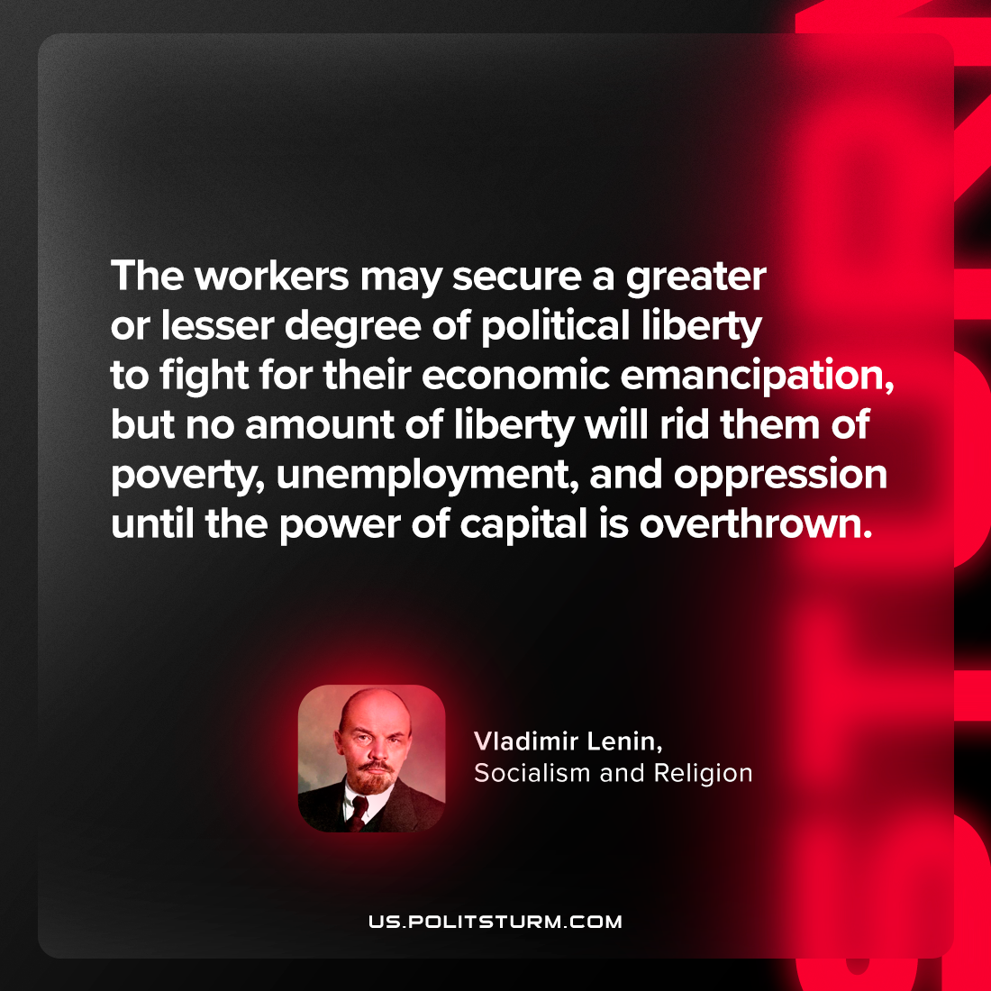

Original article
2023-11-23

"The workers may secure a greater or lesser degree of political liberty to fight for their economic emancipation, but no amount of liberty will rid them of poverty, unemployment, and oppression until the power of capital is overthrown."
Vladimir Lenin, Socialism and religion

Original article

