Lenin on the Police
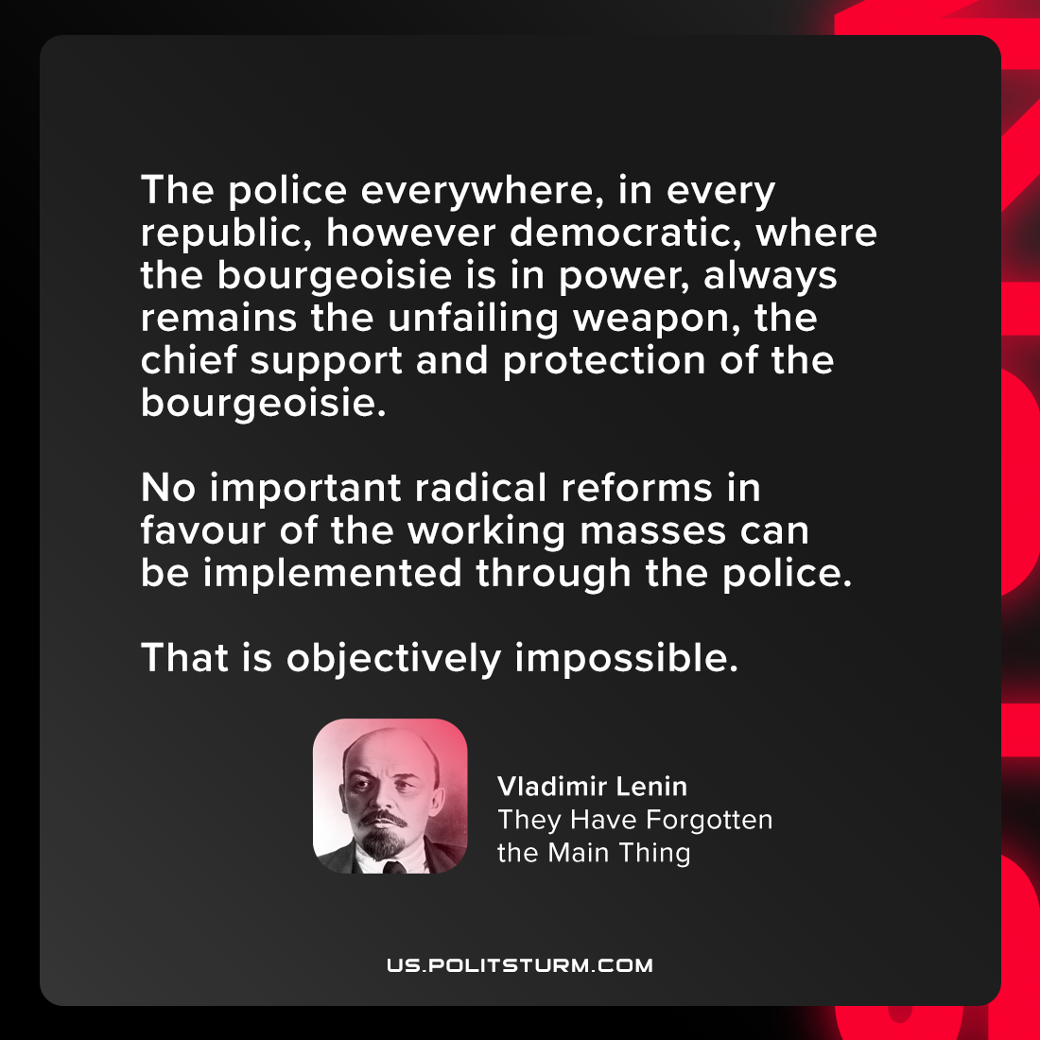

Original article
2021-08-13

The police everywhere, in every republic, however democratic, where the bourgeoisie is in power, always remains the unfailing weapon, the chief support and protection of the bourgeoisie. No important radical reforms in favour of the working masses can be implemented through the police. That is objectively impossible.

Vladimir Lenin, “They Have Forgotten the Main Thing”

Original article

